***Smart Trial Studio***

***Kashmira Chaudhari 20158***

1. **Introduction**
2. Revolutionizing the way we shop for clothing: The Smart Trial Studio offers an innovative approach to shopping.
3. The kiosk has been introduced in the project to streamline the shopping experience by allowing customers to browse products, manage their cart, and place orders directly from an intuitive interface.
4. Enhanced Shopping Experience: This service reduces the time and hassle of traditional shopping while enhancing the overall experience with personalized convenience and flexibility
5. API Development Goals:

• CRUD Operations: My goal is to develop API’s that can perform different operations like Create, Read, Update, and Delete (CRUD) on the database.

• Access Control:

o READ Access: Available to both employees and customers.

o CREATE, UPDATE, and DELETE Access: Restricted to store employees only.

1. **Tech Stack:**
2. **Sprinboot:** Java Spring Boot is an open-source tool that makes it easier to use Java-based frameworks to create microservices and web apps.
3. **Mongodb:** MongoDB is the document database designed to make it easy for developers to work with data in any form, and from any programming language.
4. **Java:** Java is a versatile, object-oriented programming language designed for building platform-independent, secure, and high-performance applications.
5. **HTML:** HTML (HyperText Markup Language) is the standard language used to create and structure content on the web by defining elements like text, images, and links.
6. **JavaScript:** JavaScript is a dynamic, high-level programming language primarily used to create interactive and responsive behavior on web pages.
7. **CSS:** CSS (Cascading Style Sheets) is a stylesheet language used to control the presentation, layout, and design of HTML elements on a web page.
8. **Architecture Diagram:**

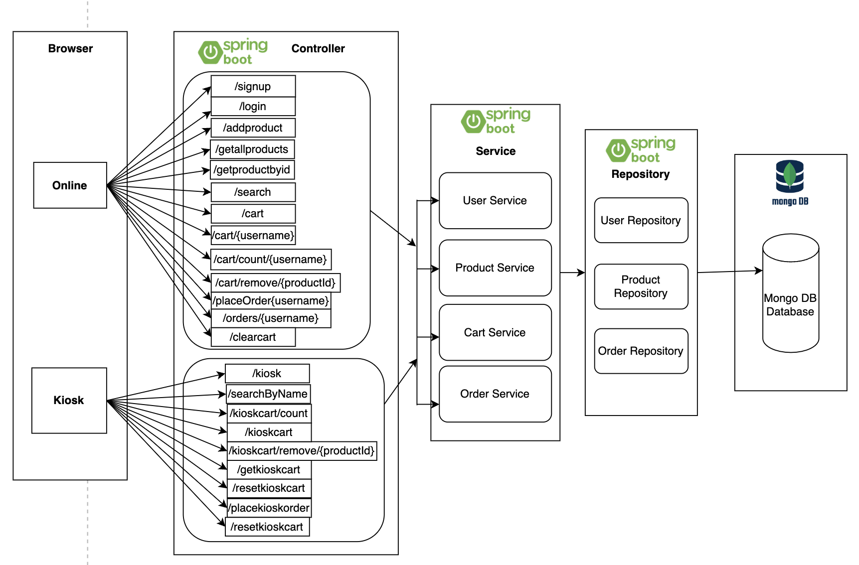

**Fig: Architecture of Smart Trial Studio**

1. **Use Case for Smart Trial Studio**

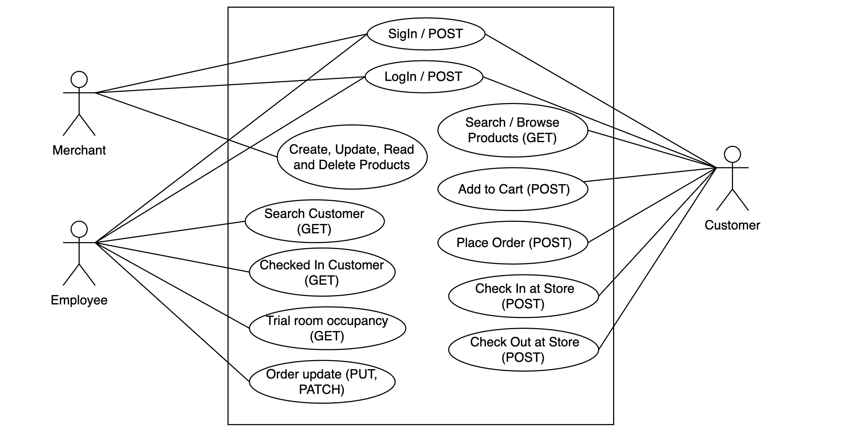

Fig: Smart Trial Studio

1. **FLOW chart:**
2. **User/Customer Flowchart**

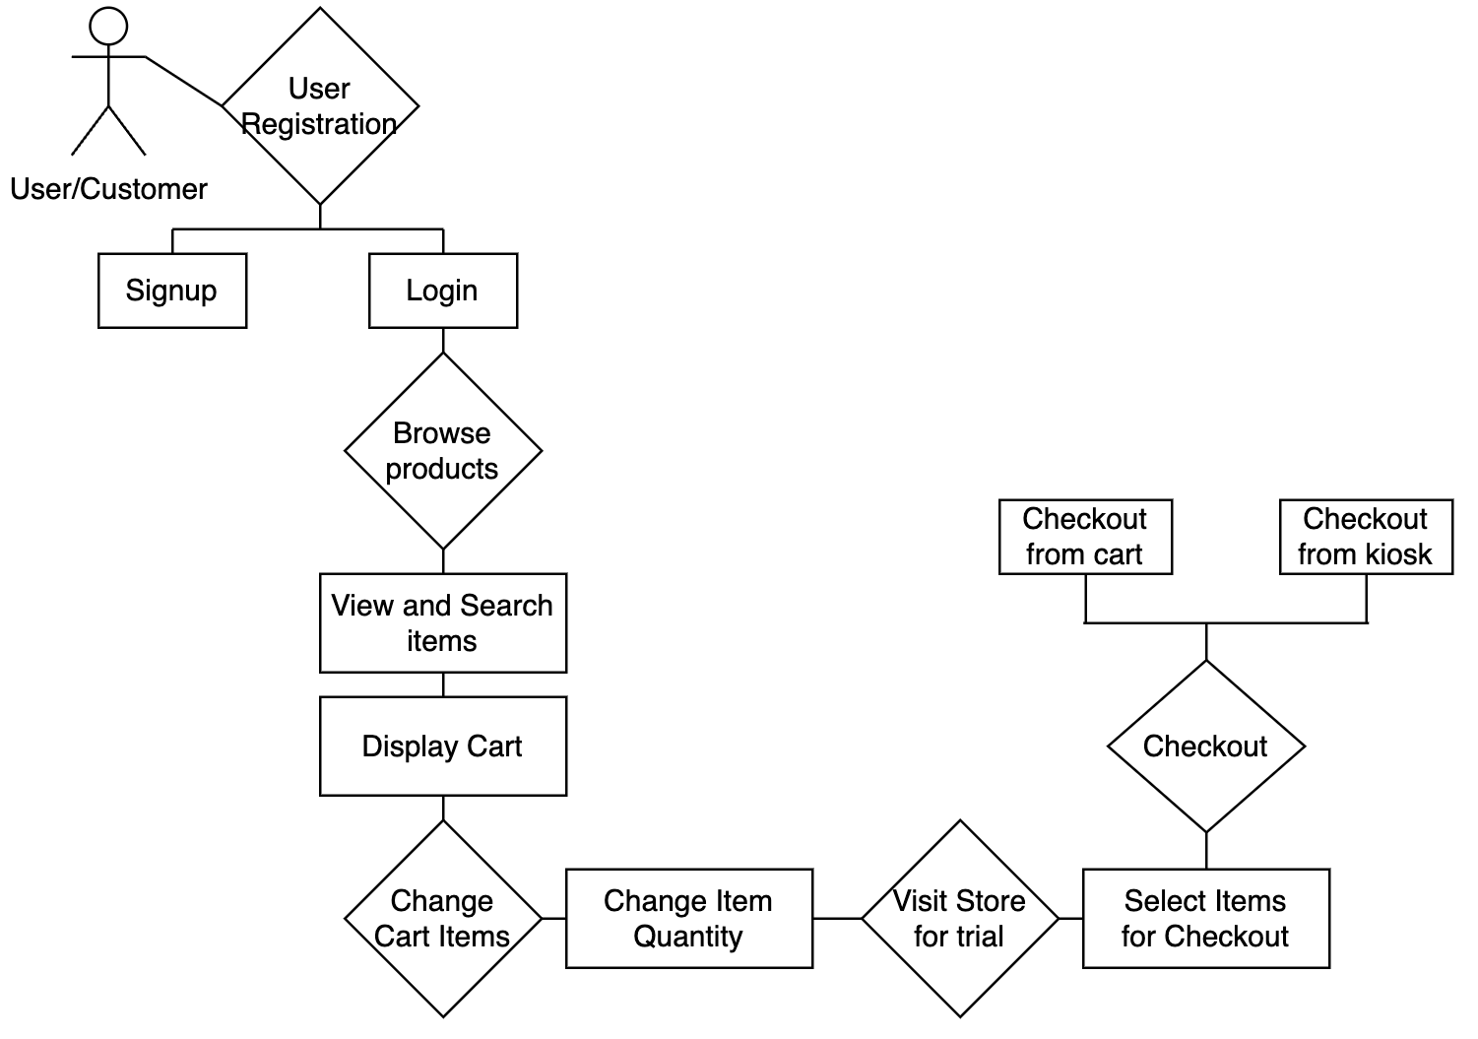

Fig: Flowchart for Customer

1. **Store Flowchart:**

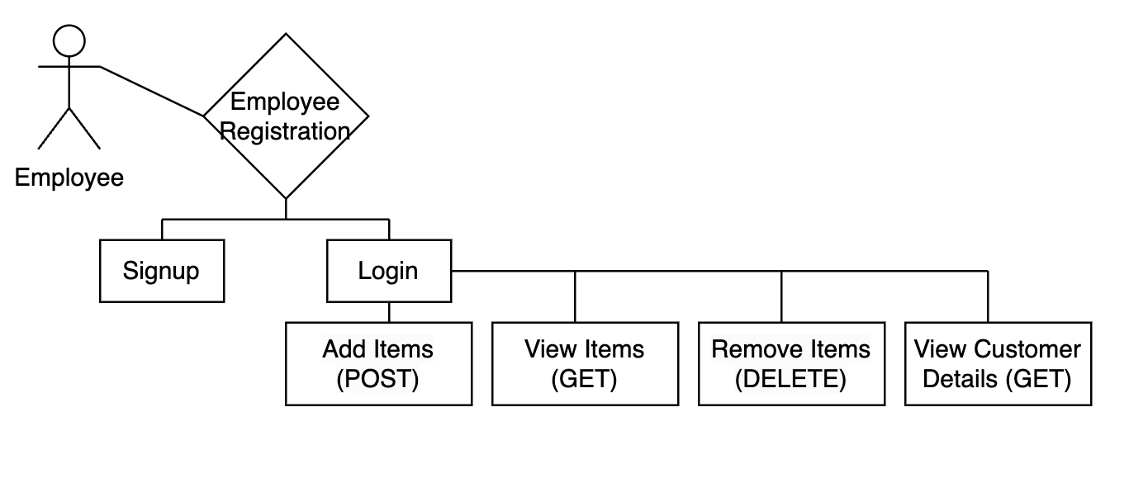

Fig: Flowchart for Store Employee

1. **Setting up MongoDB:**

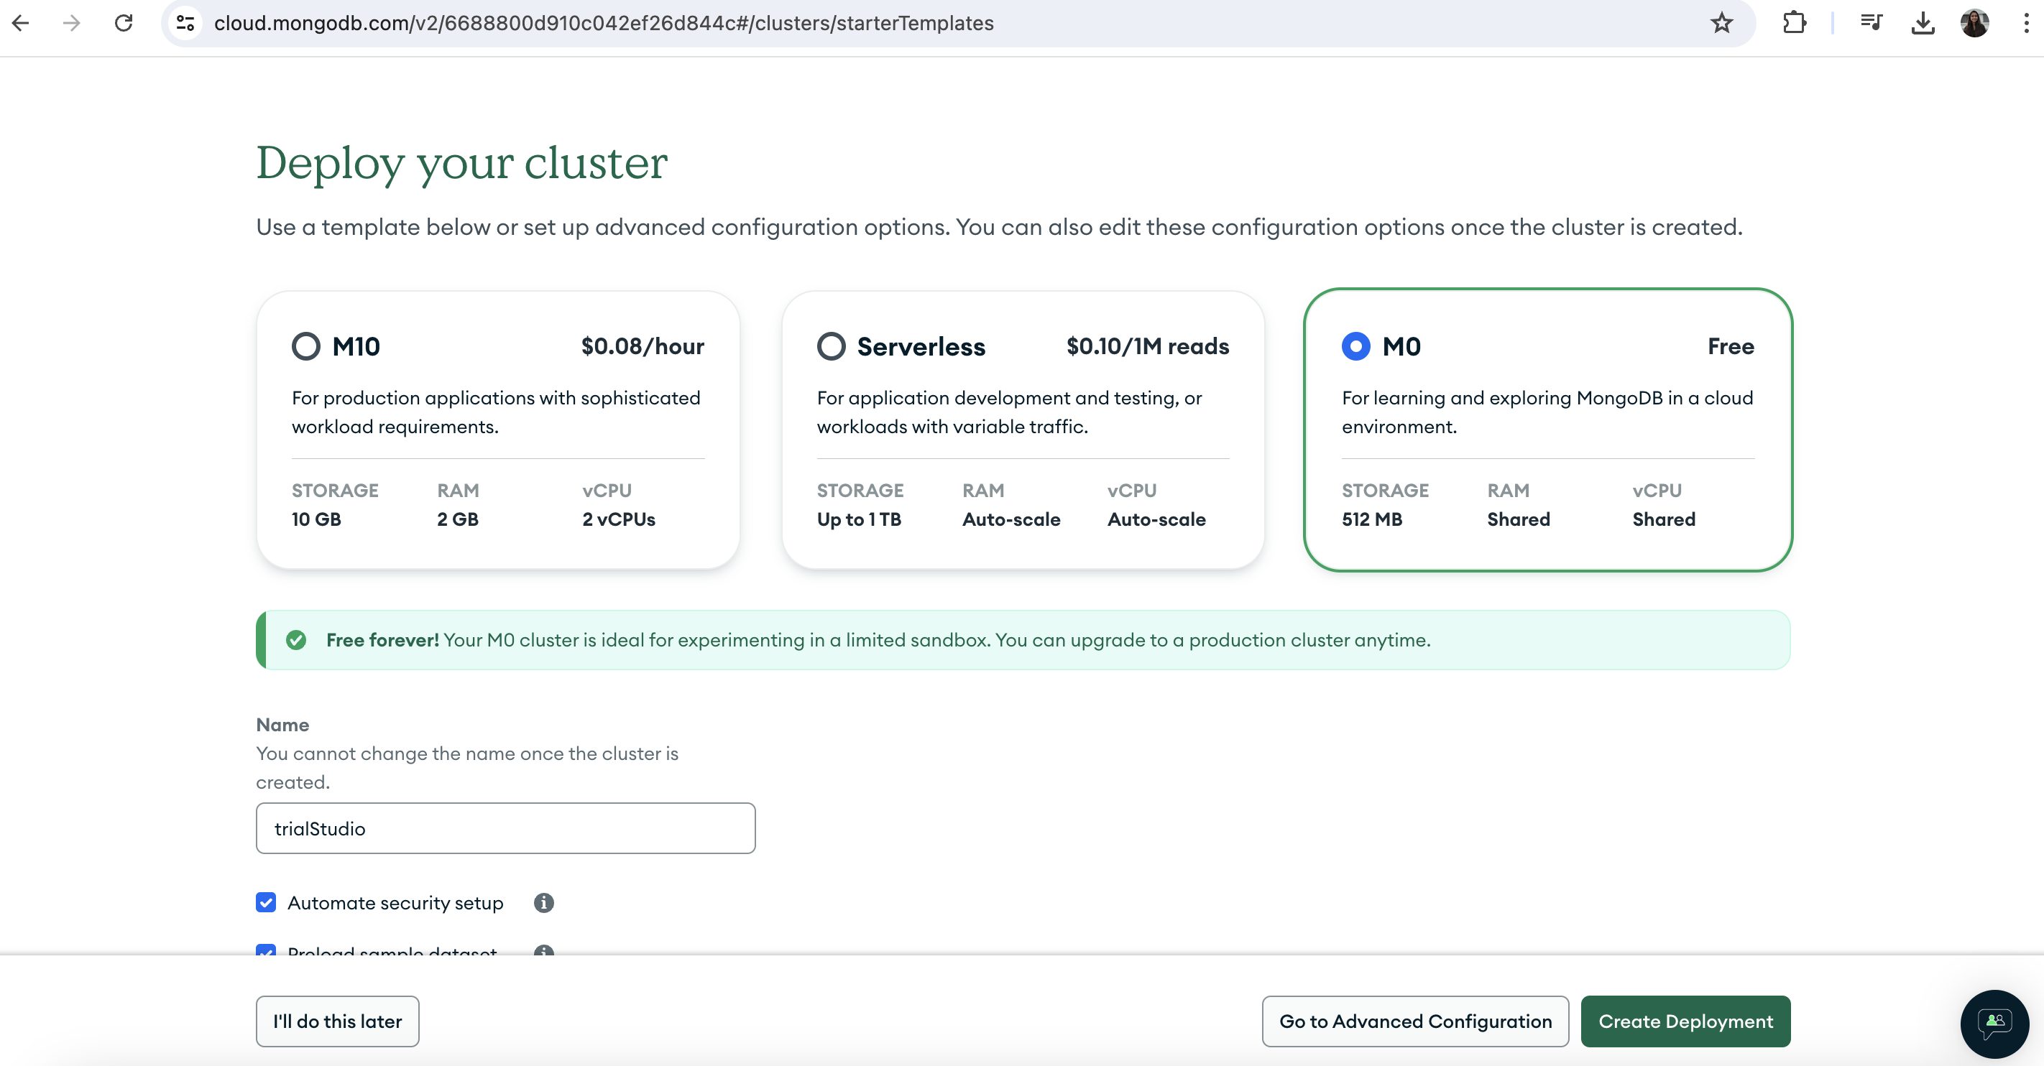

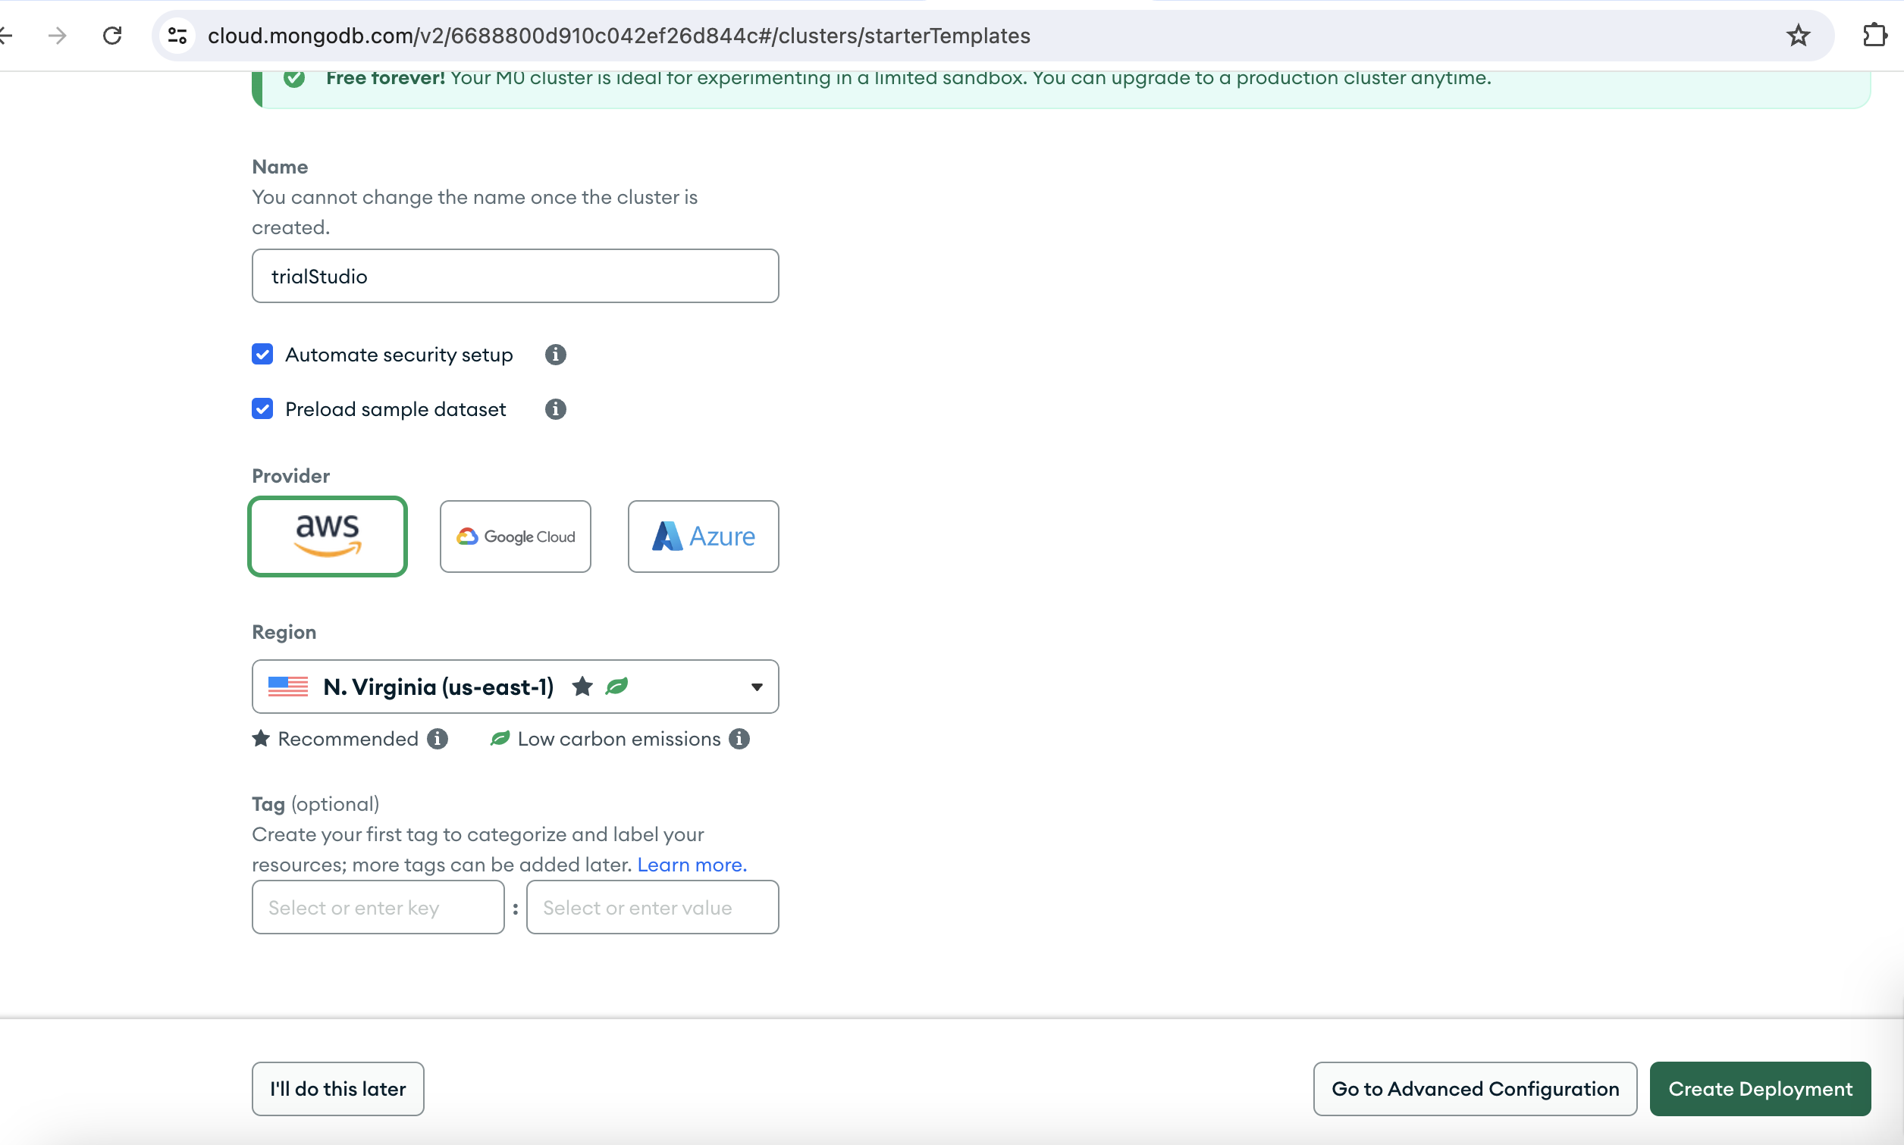

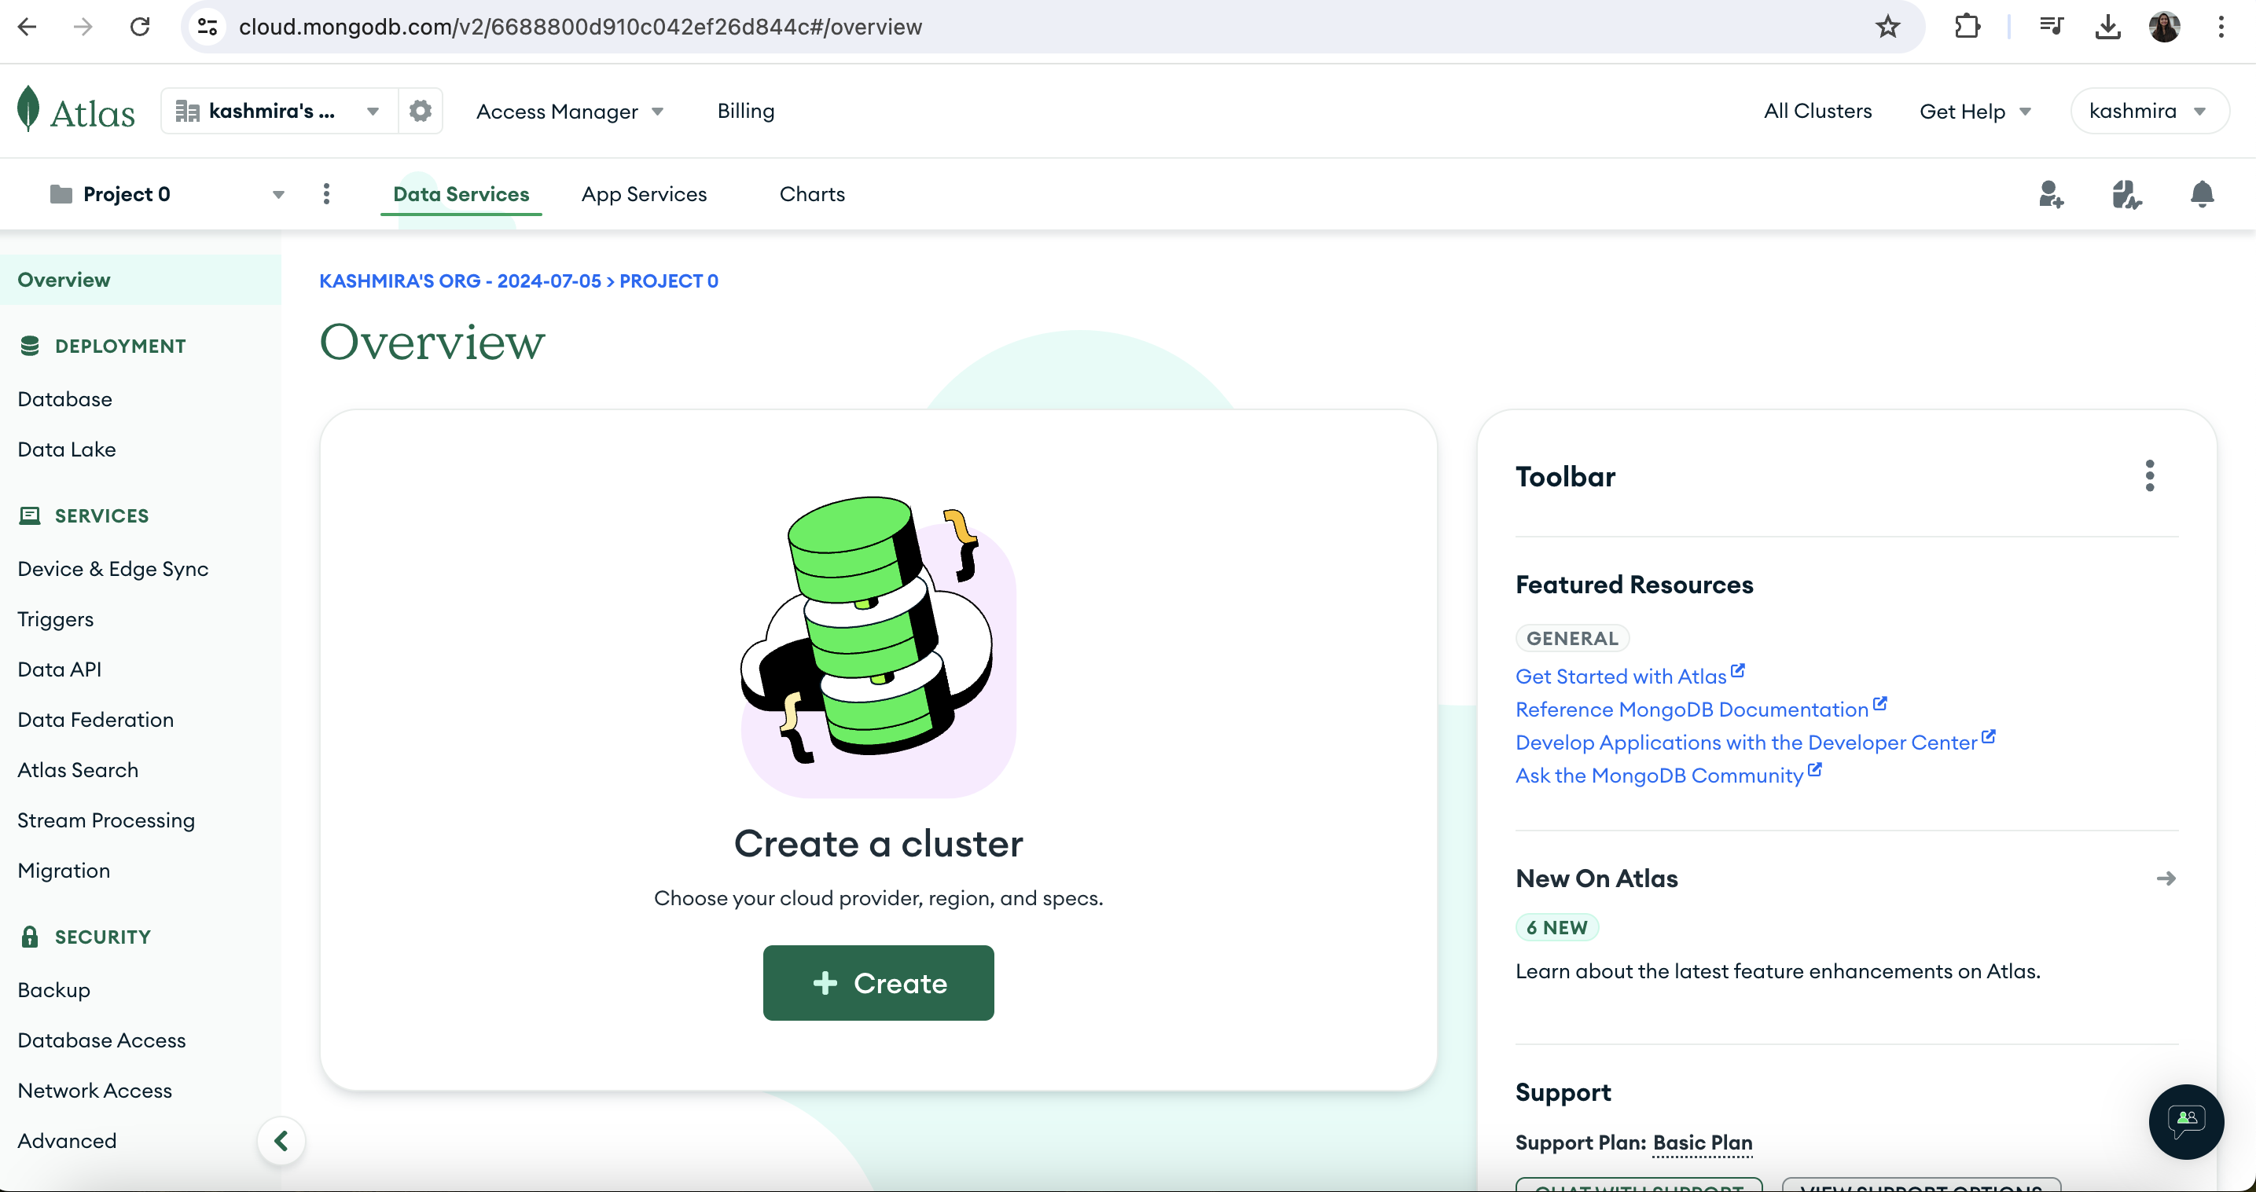

1. **Created a database named “trialStudio”**

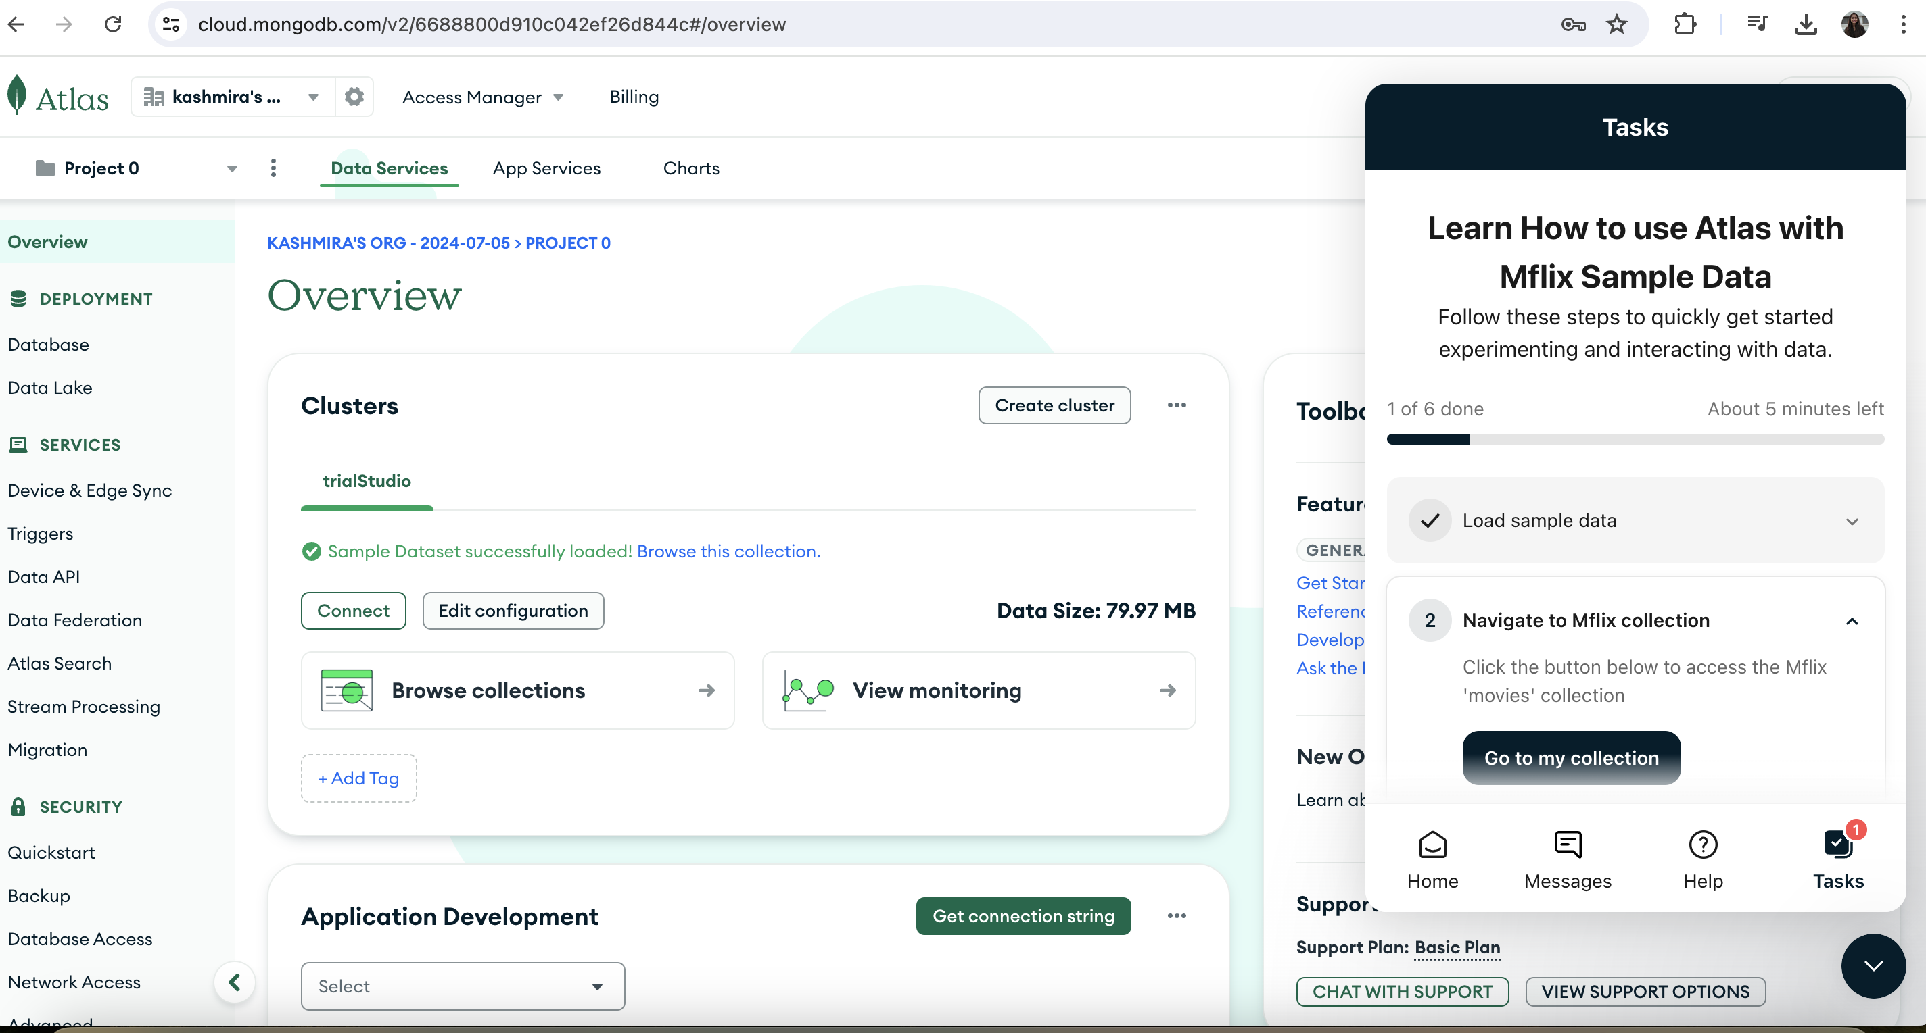

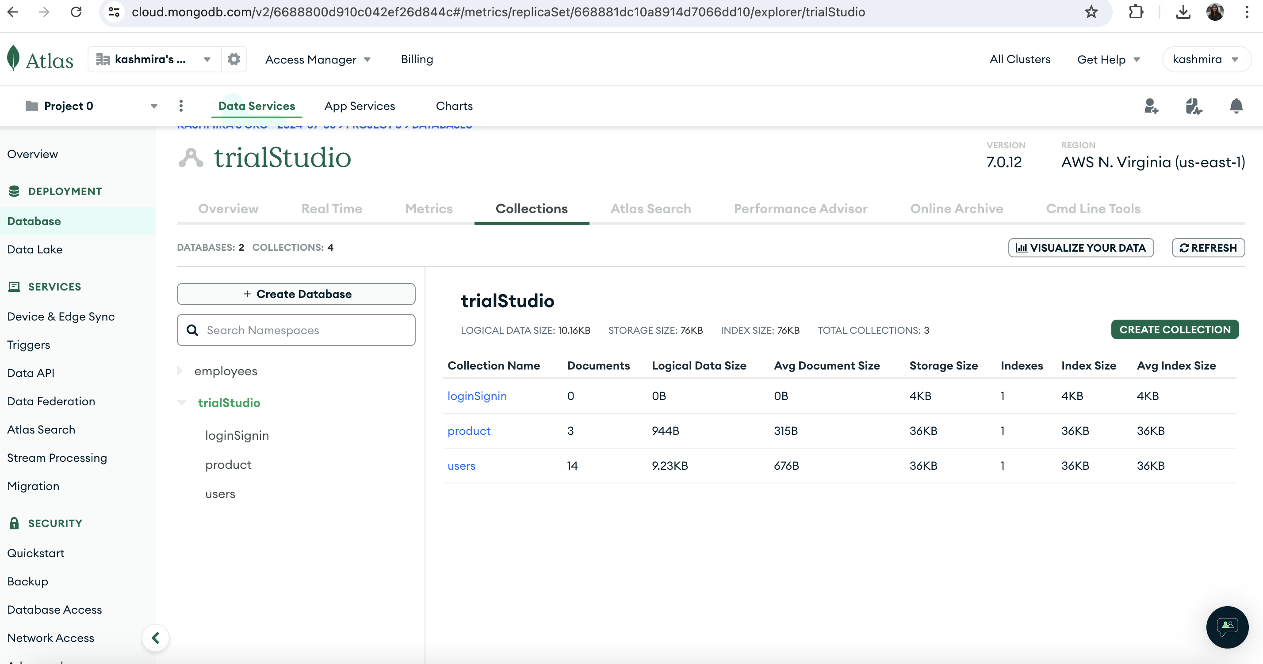

1. **Create a project using** <https://start.spring.io/>

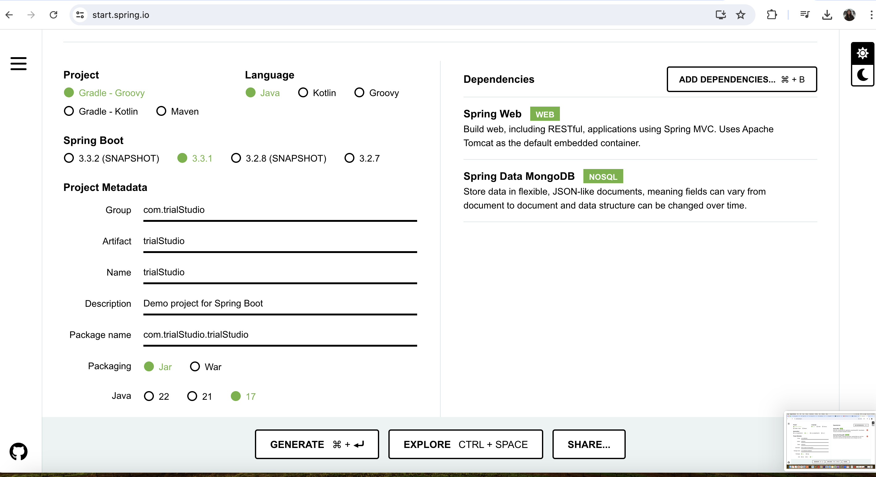

1. **Project Structure:**

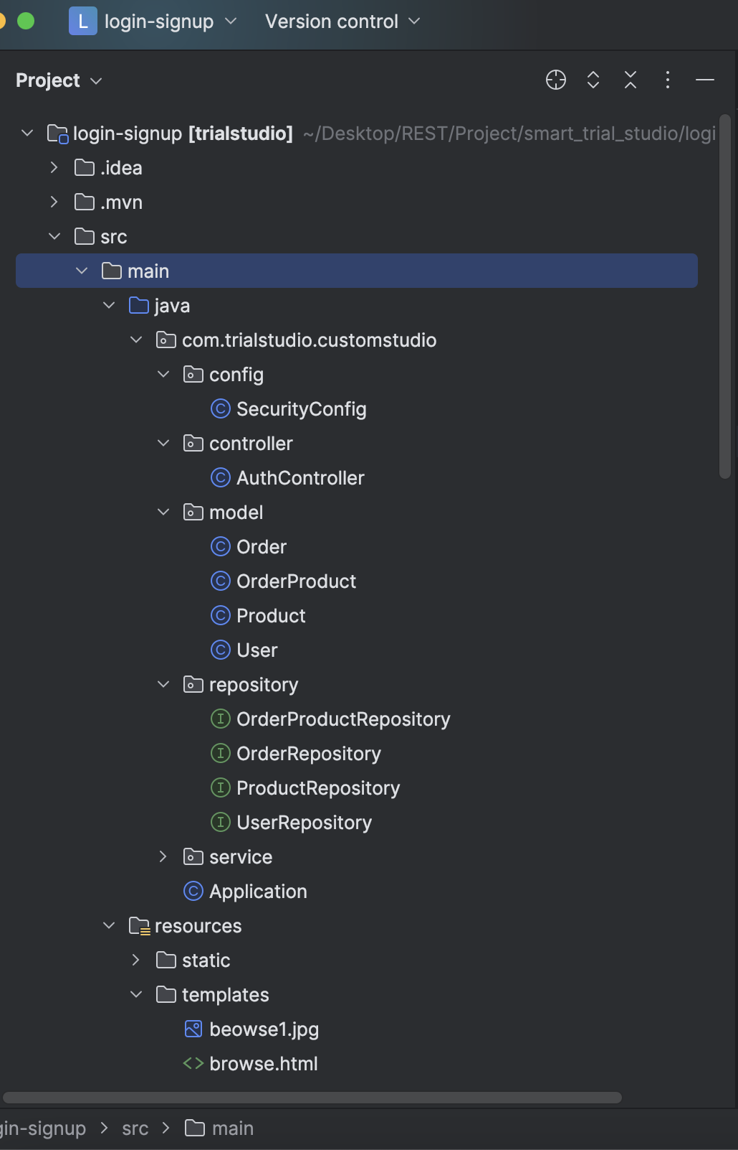

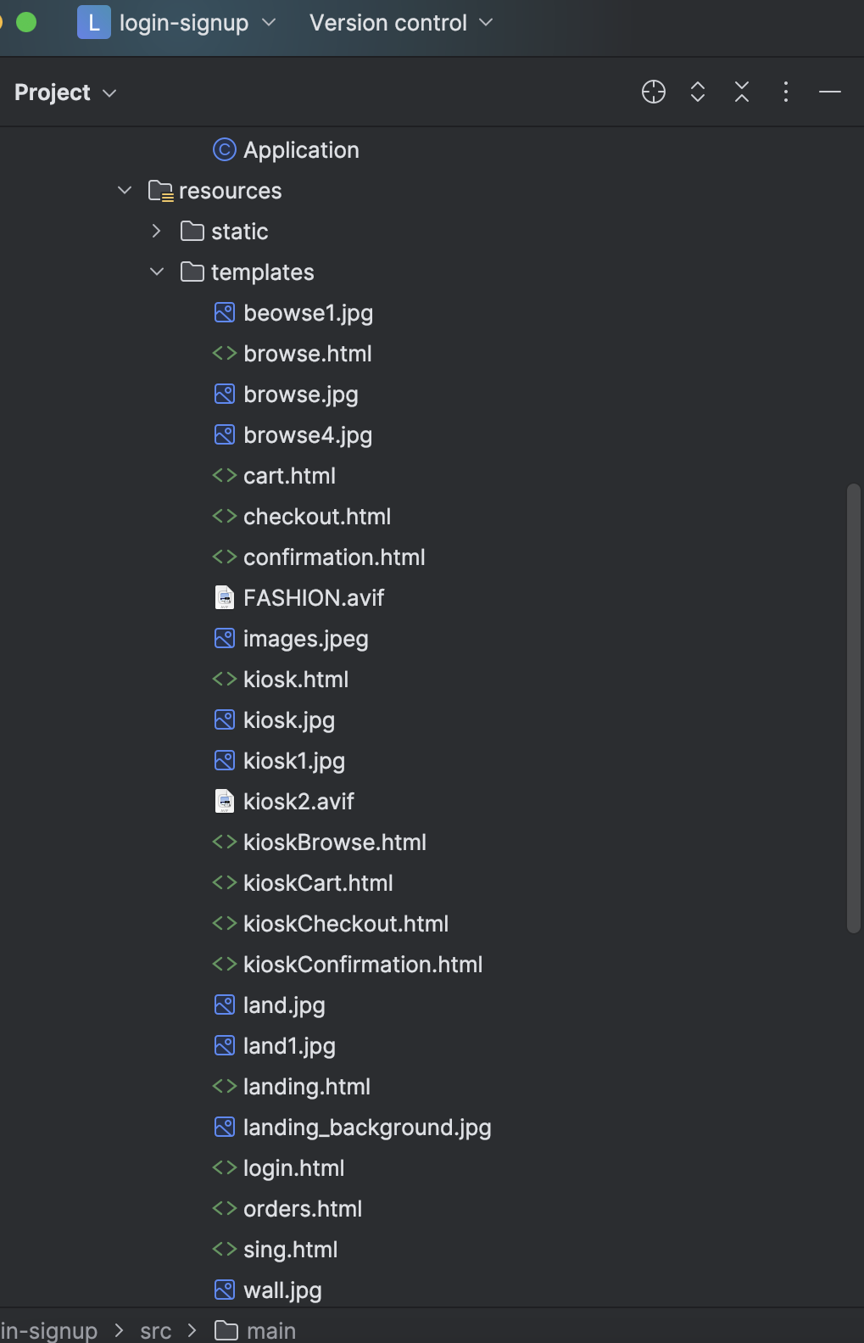

1. **Created below listed API End points:**
   * 1. @PostMapping("/signup") => api/auth/signup
     2. @PostMapping("/login") => api/auth/login
     3. @PostMapping("/addproduct") => /api/auth/addproduct
     4. @GetMapping("/getallproducts") => /api/auth/getallproducts
     5. @GetMapping("/getproductbyid") => /api/auth/getproductbyid
     6. @DeleteMapping("/deleteproductbyid") => /api/auth/deleteproductbyid
     7. @GetMapping("/search") => /api/auth/search
     8. @PutMapping("/{id}") => /api/auth/{id}
     9. @PatchMapping("/{id}") => /api/auth/{id}
     10. @GetMapping("/login")
     11. @GetMapping("/signup")
     12. @PostMapping("/cart")
     13. @GetMapping("/cart/{username}")
     14. @GetMapping("/cart/count/{username}")
     15. @GetMapping("/kiosk/count")
     16. @GetMapping("/searchByName")
     17. @GetMapping("/searchByName")
     18. @PostMapping("/kioskcart")
     19. @DeleteMapping("/kioskcart/remove/{productId}")
     20. @GetMapping("/getkioskcart")
     21. @GetMapping("/kioskcart/count")
     22. @GetMapping("/resetkioskcart")
     23. @PostMapping("/placeOrder/{username}")
     24. @GetMapping("orders/{username}")
     25. @PostMapping("/placekioskorder")
     26. @PostMapping("/clearcart")
     27. @PostMapping("/resetkioskcart")
2. **AuthController code to write API’s:**

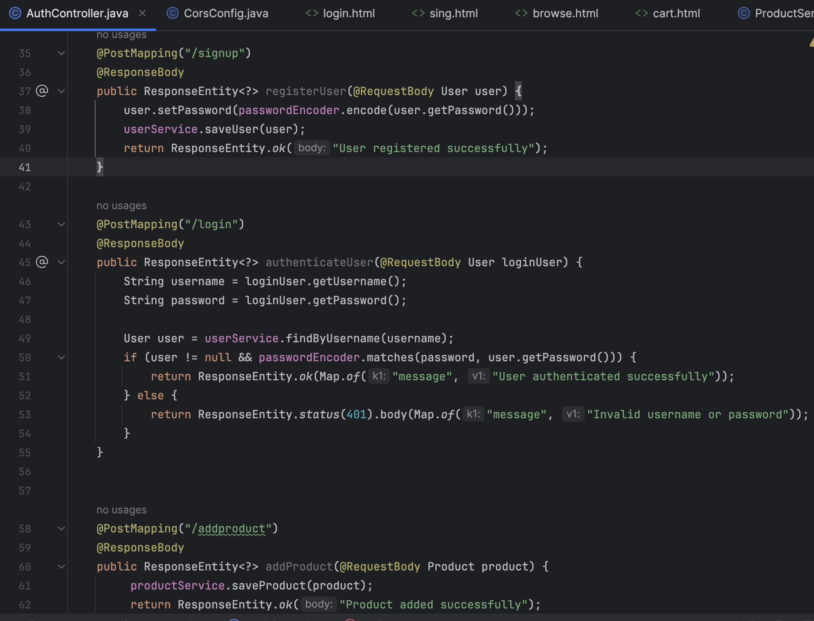

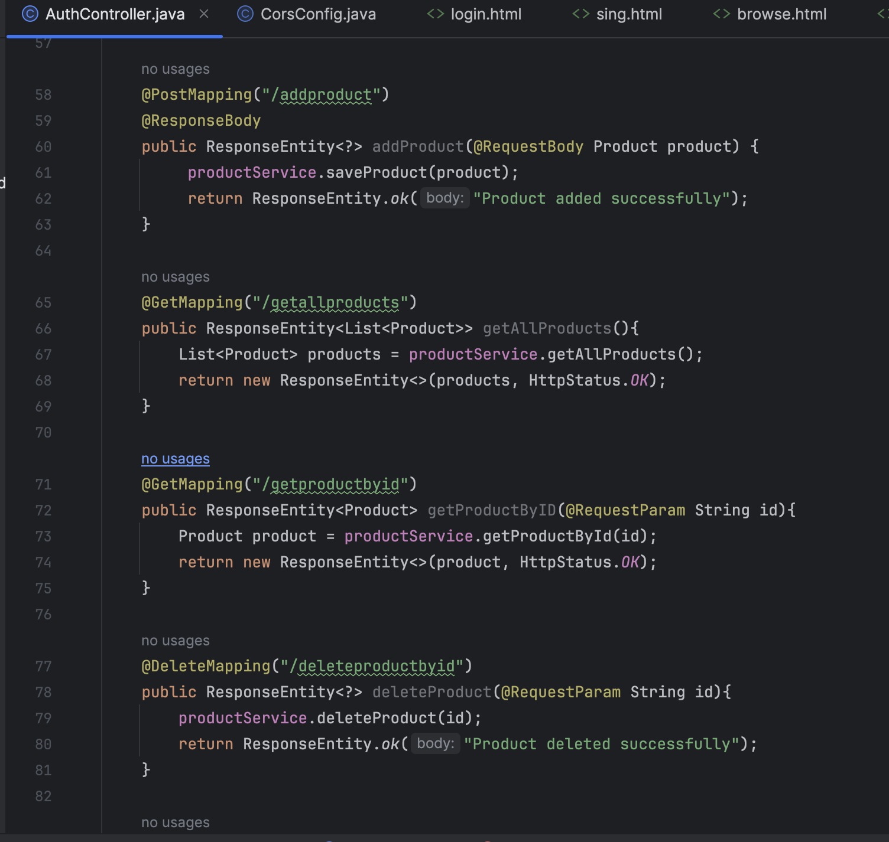

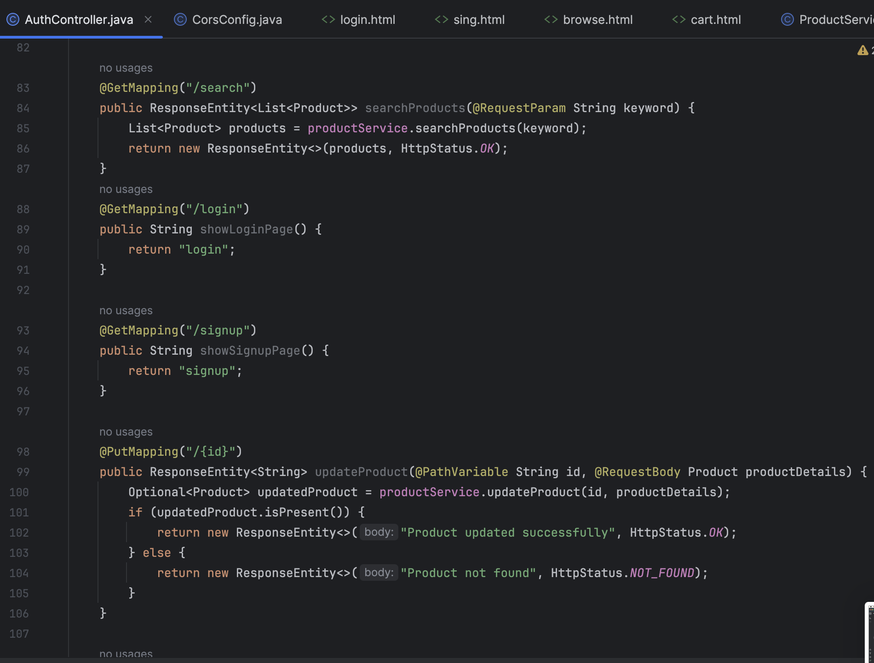

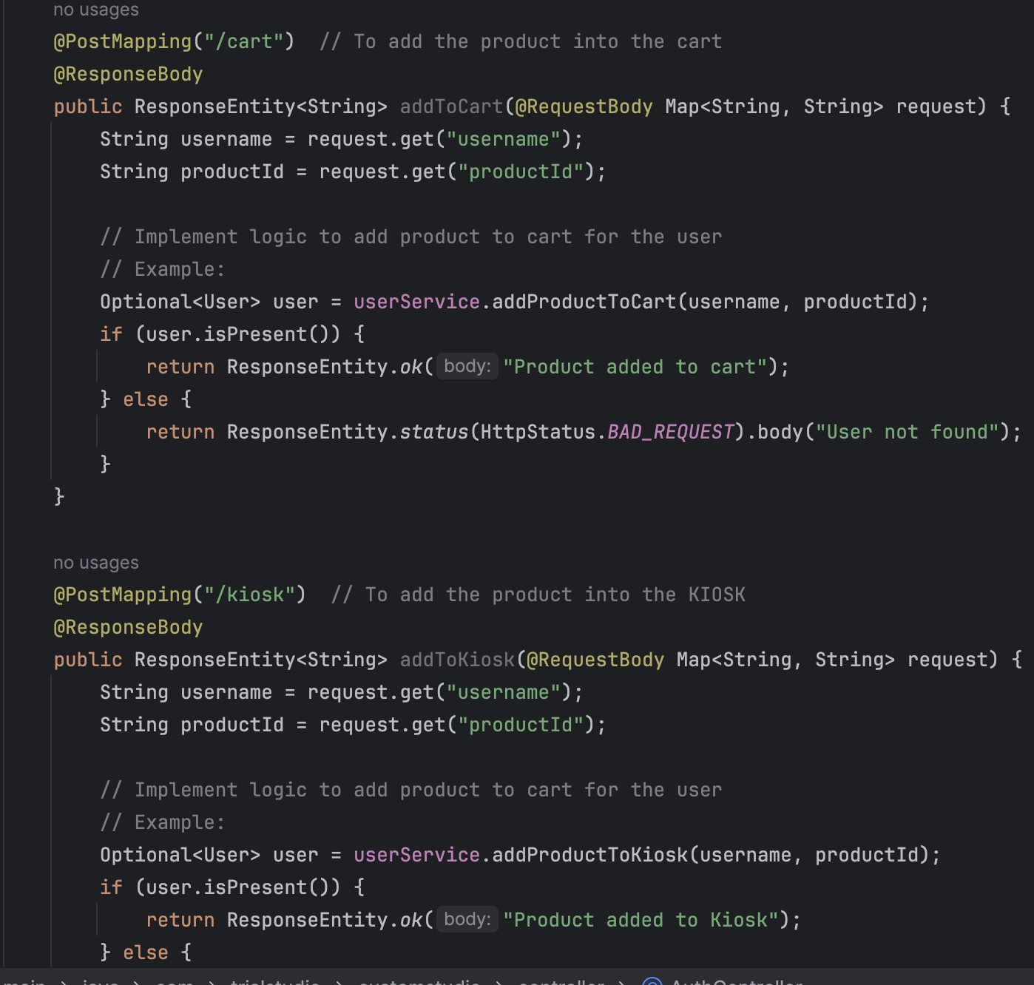

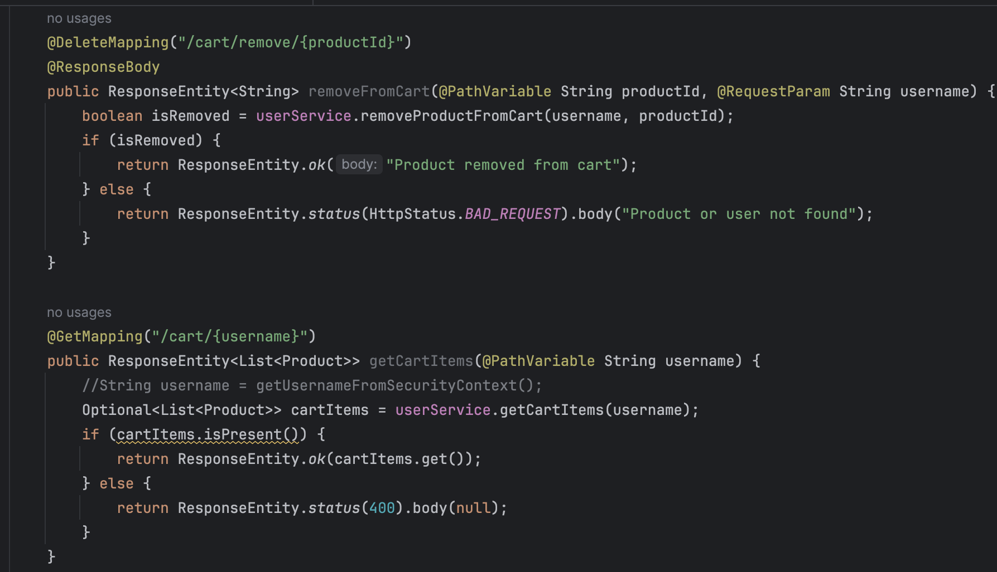

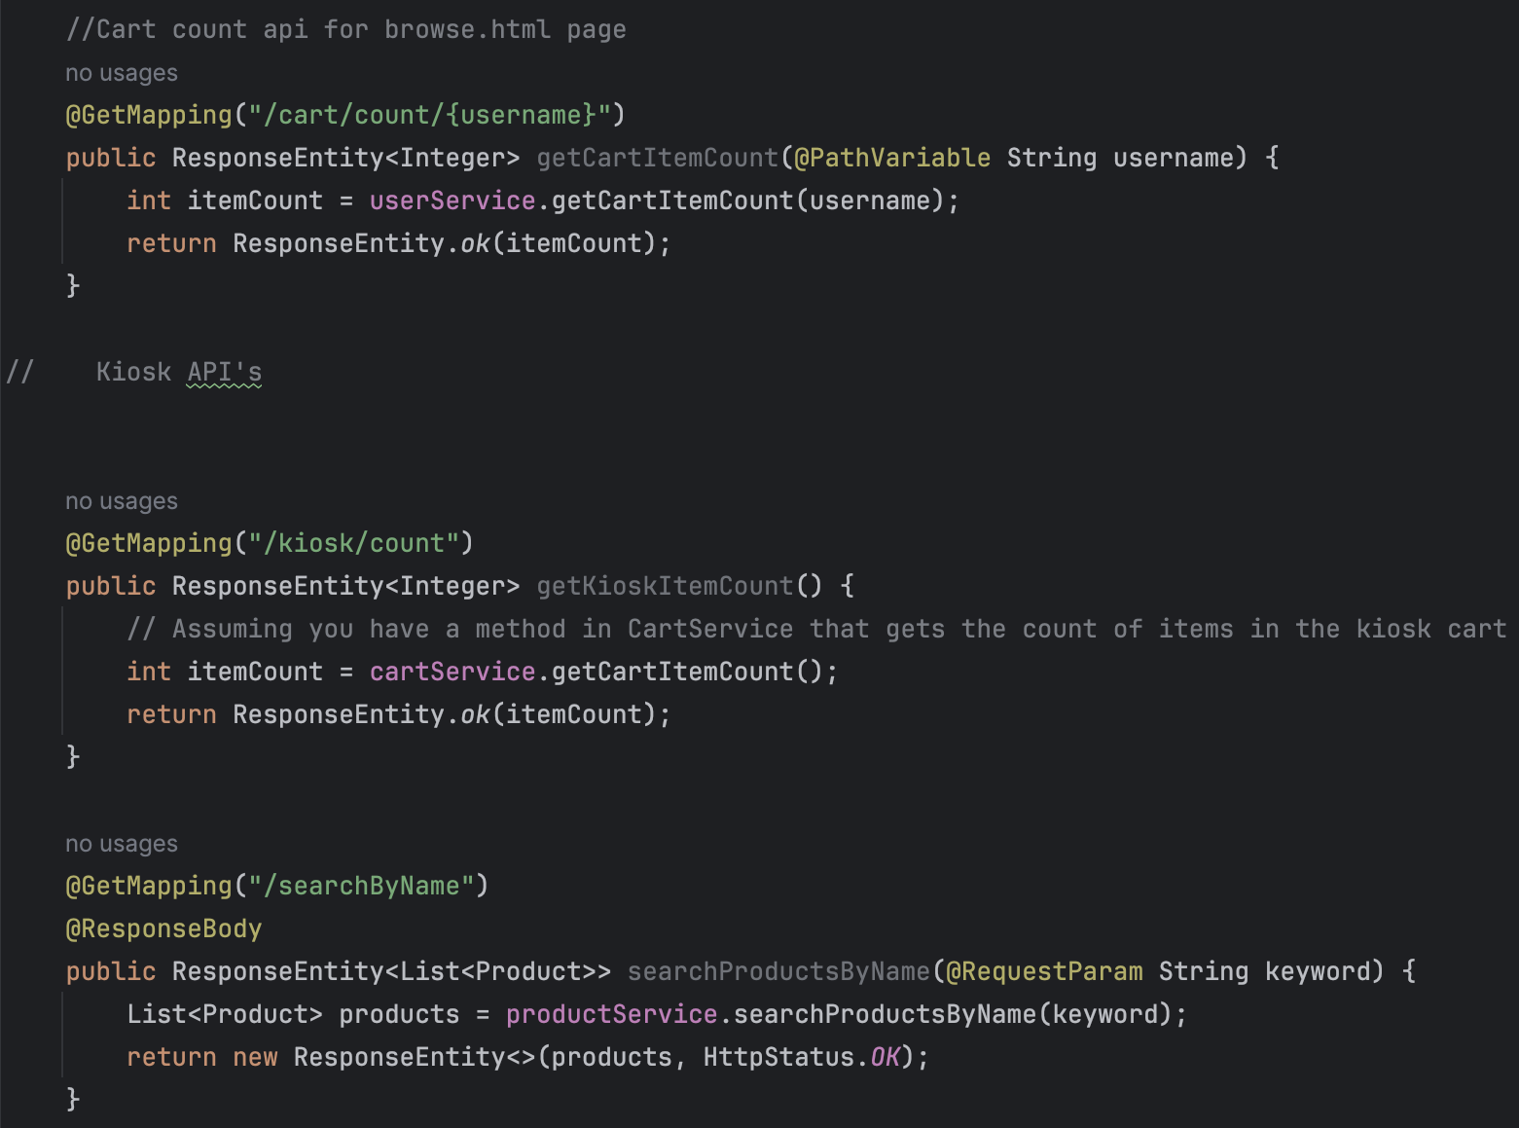

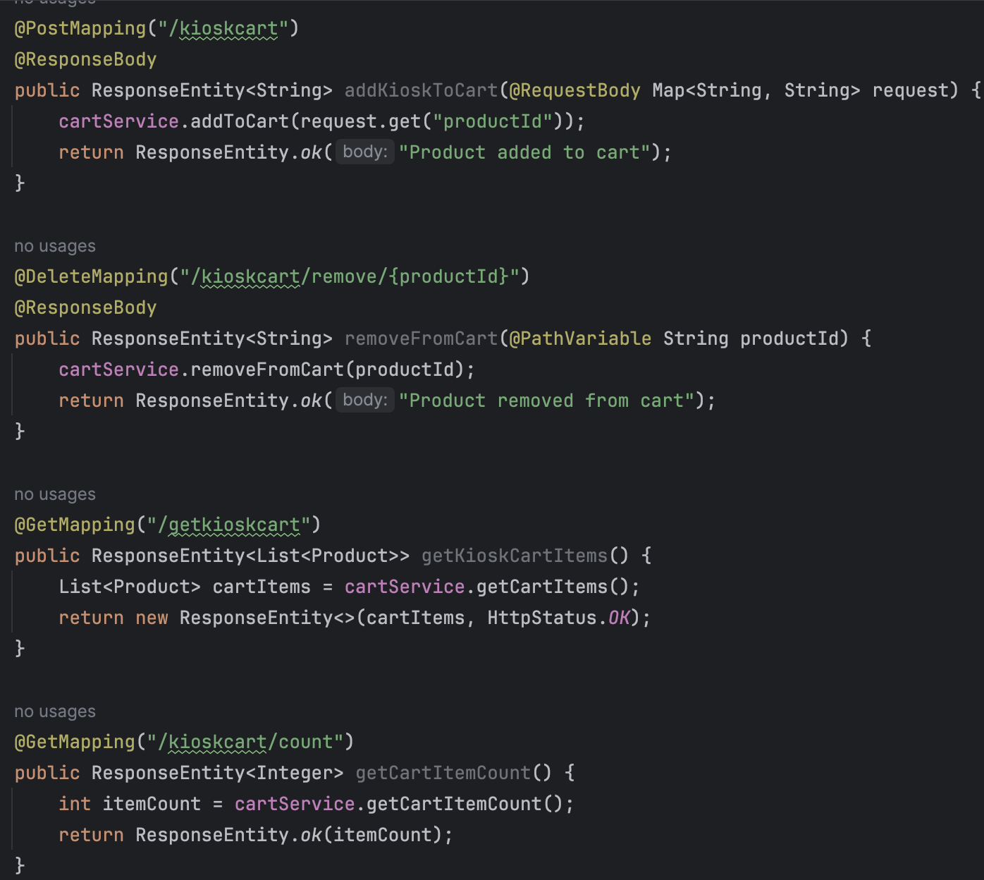

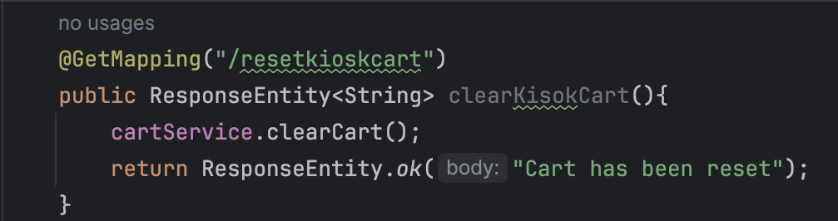

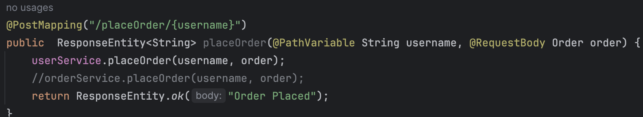

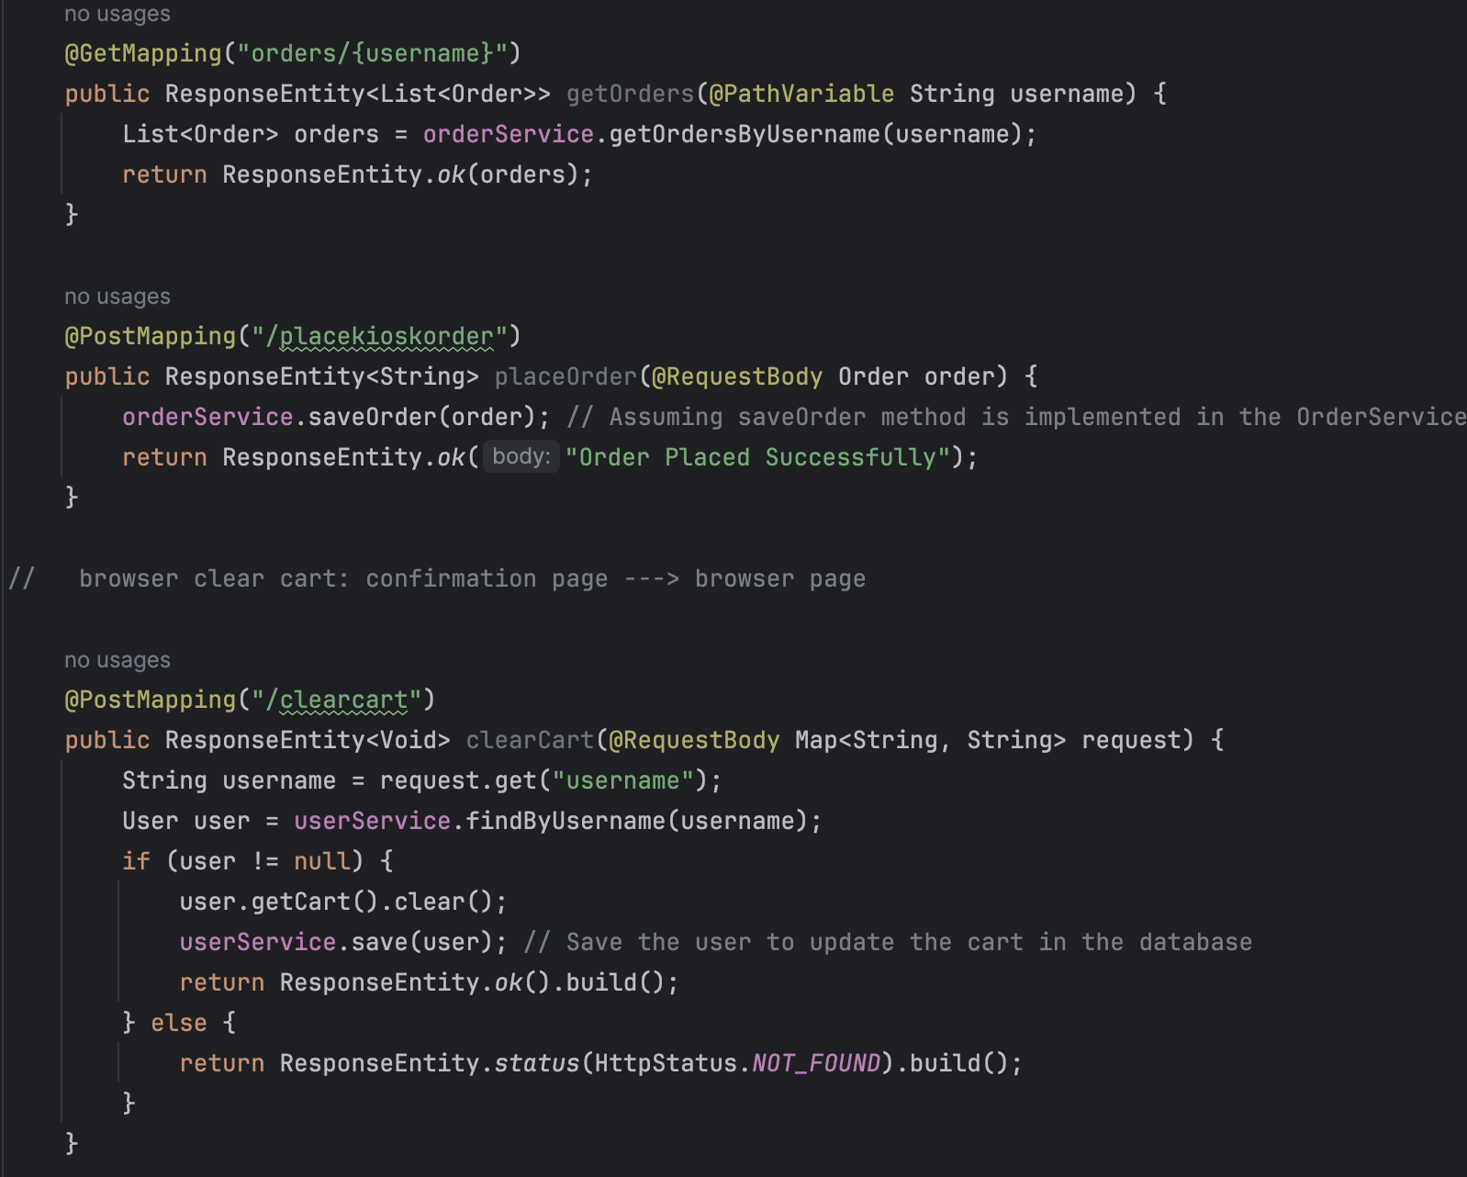

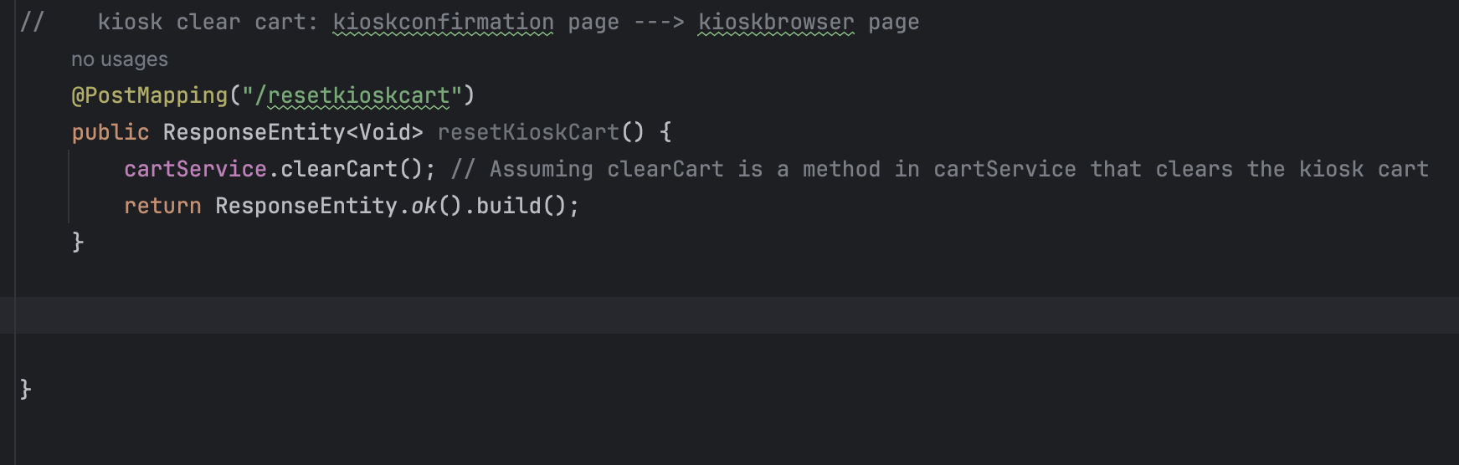

1. **API response on Postman:**

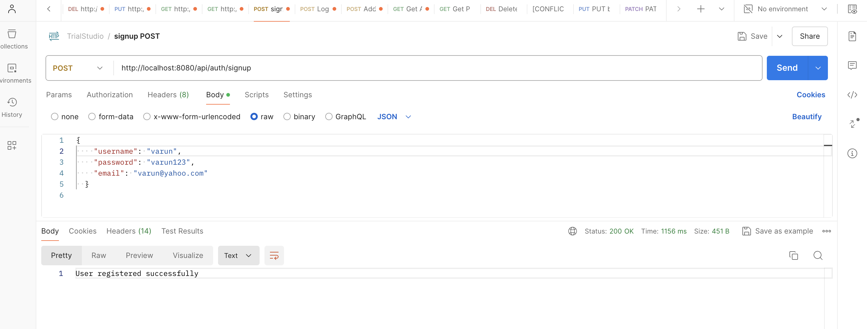

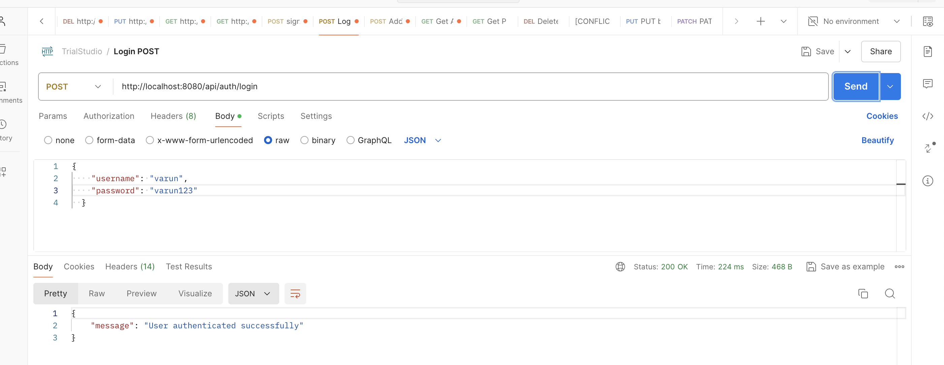

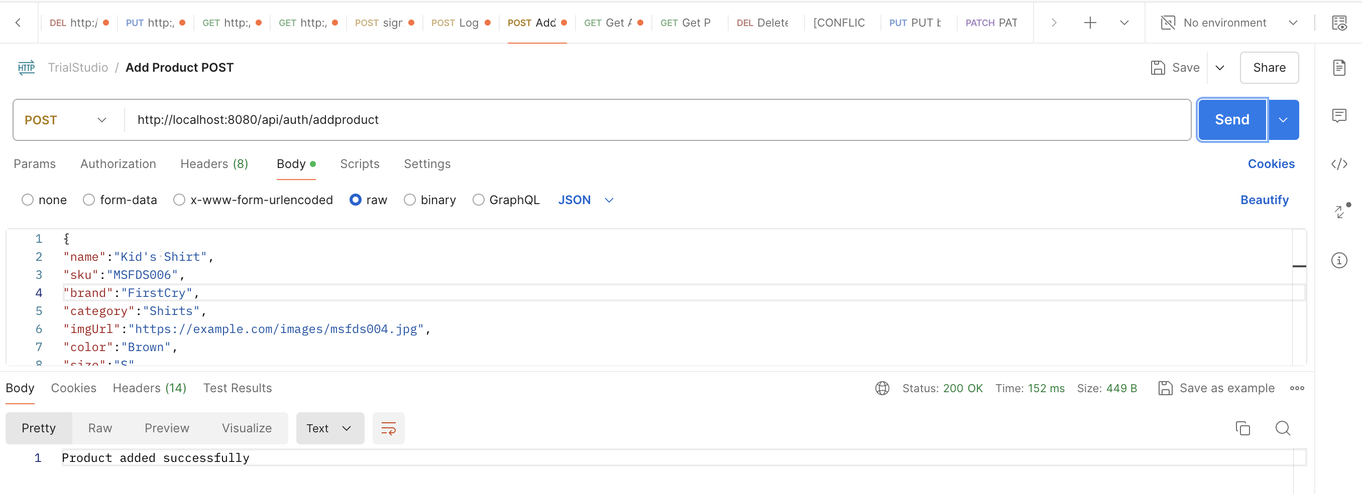

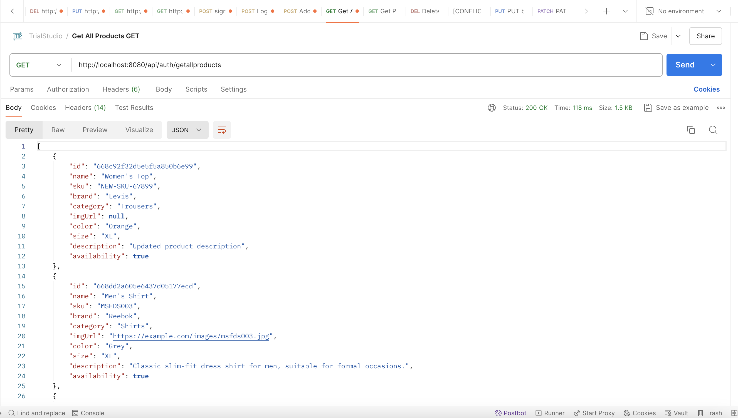

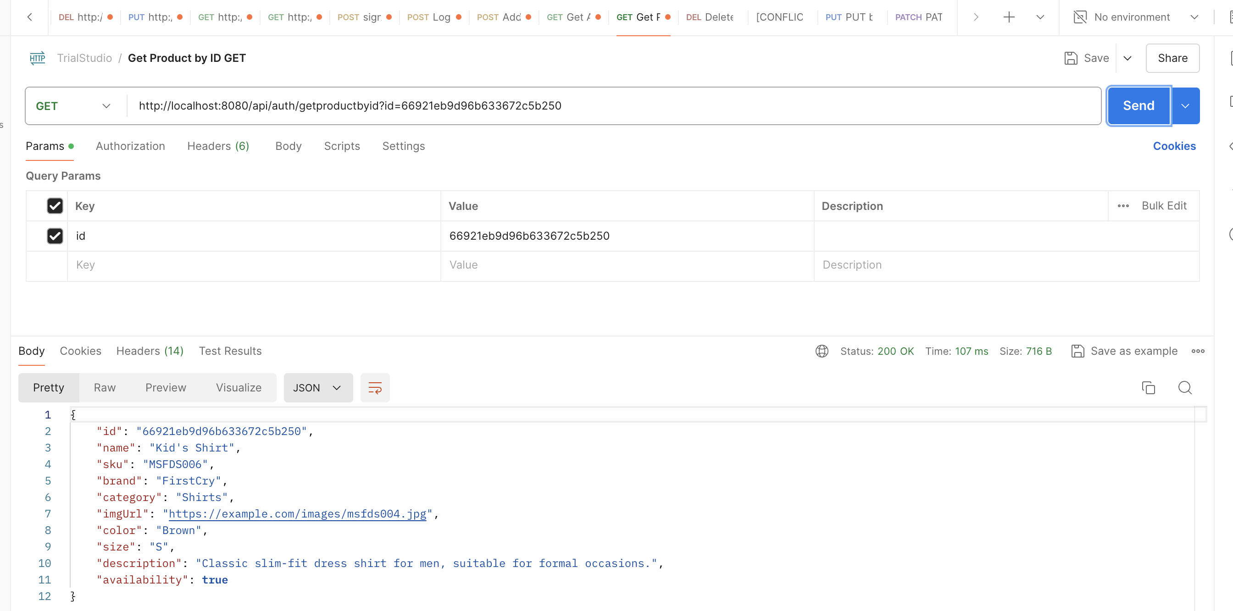

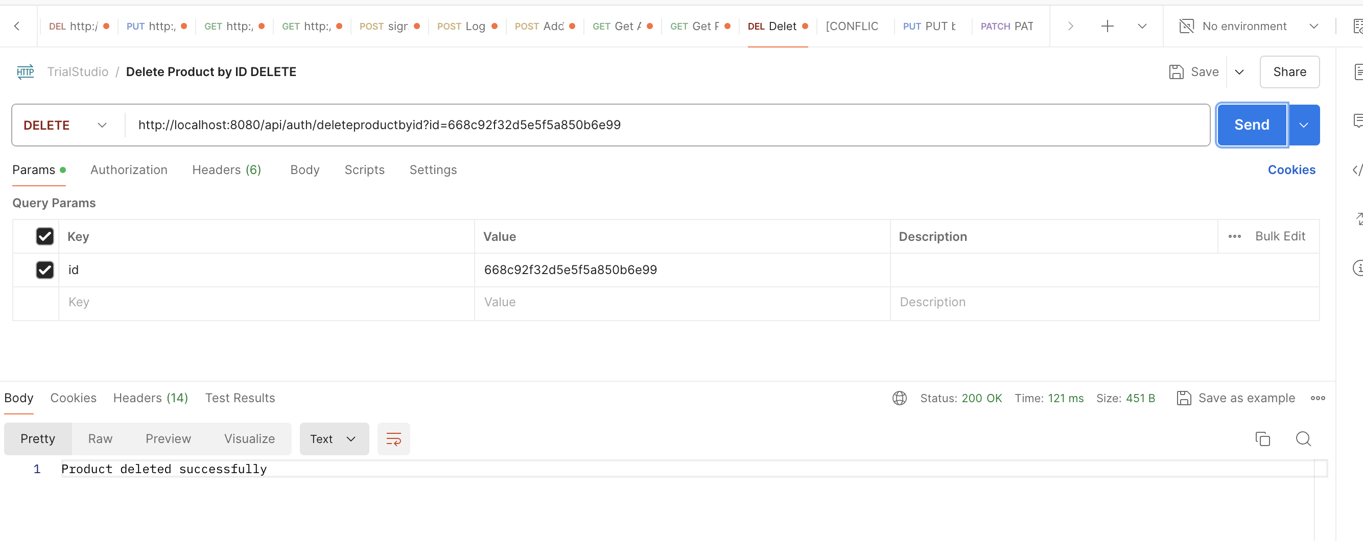

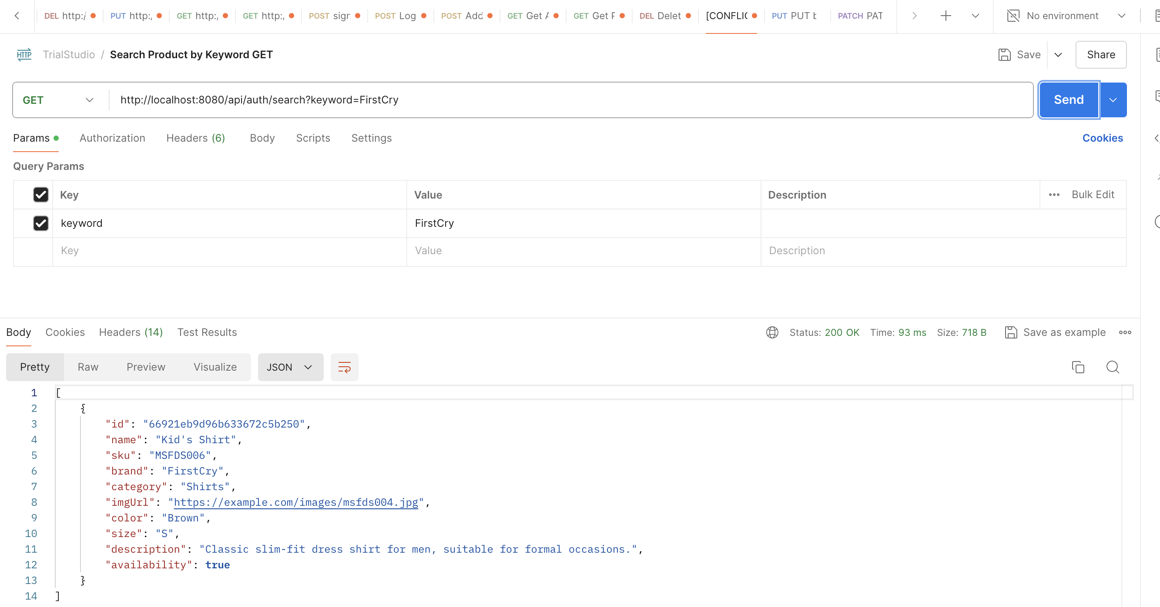

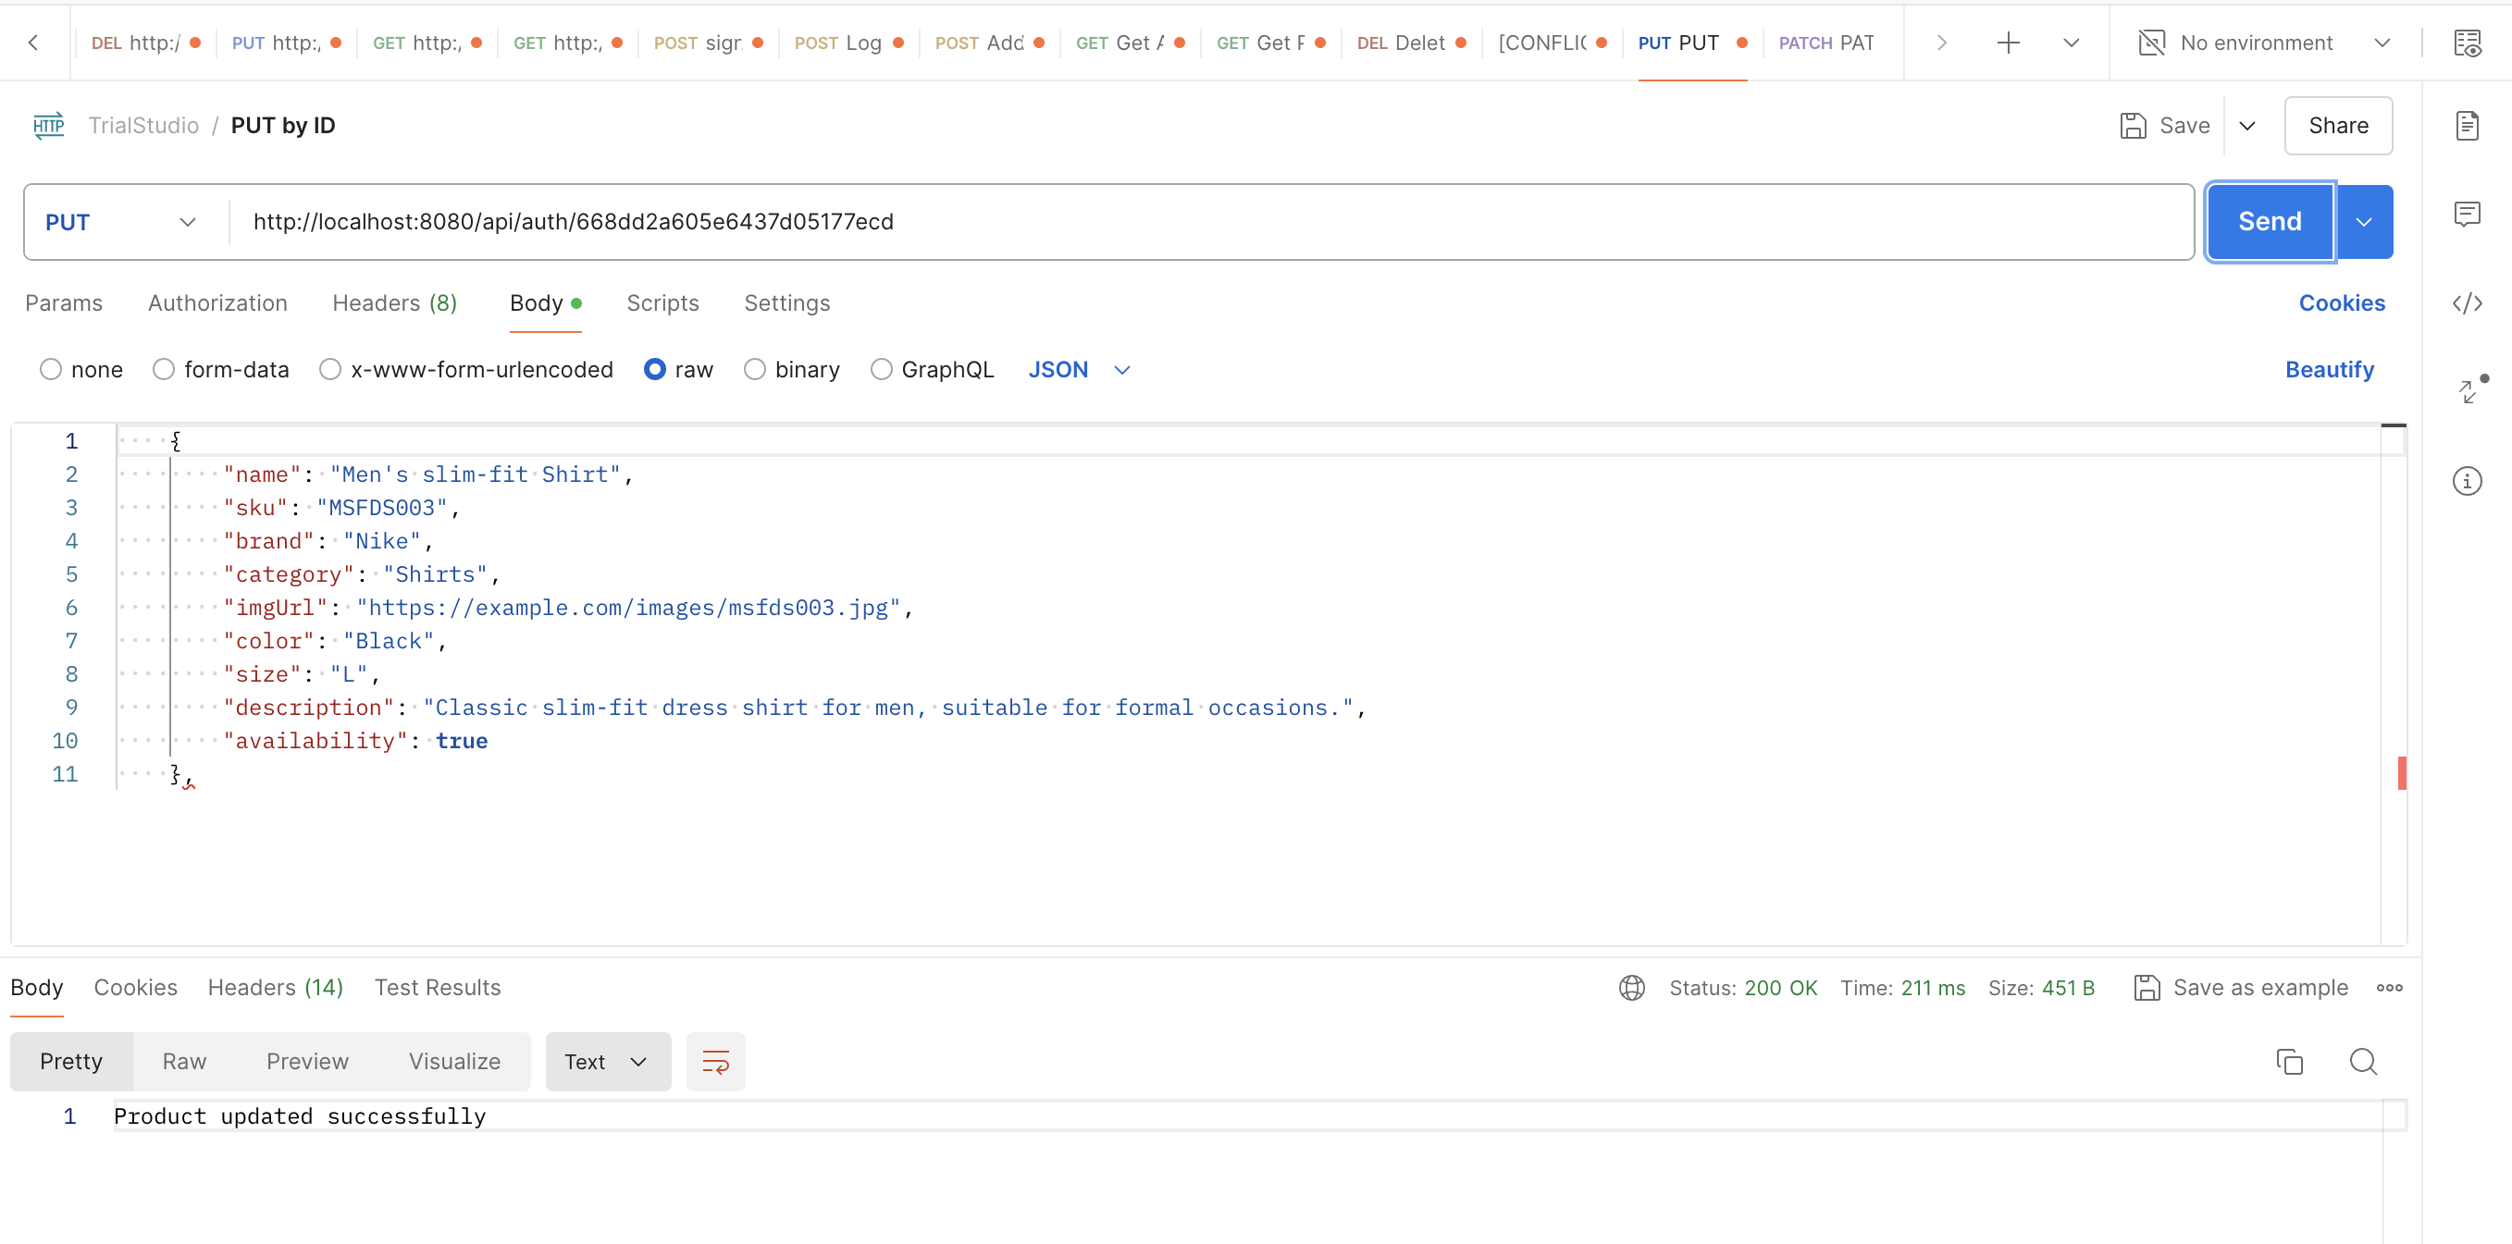

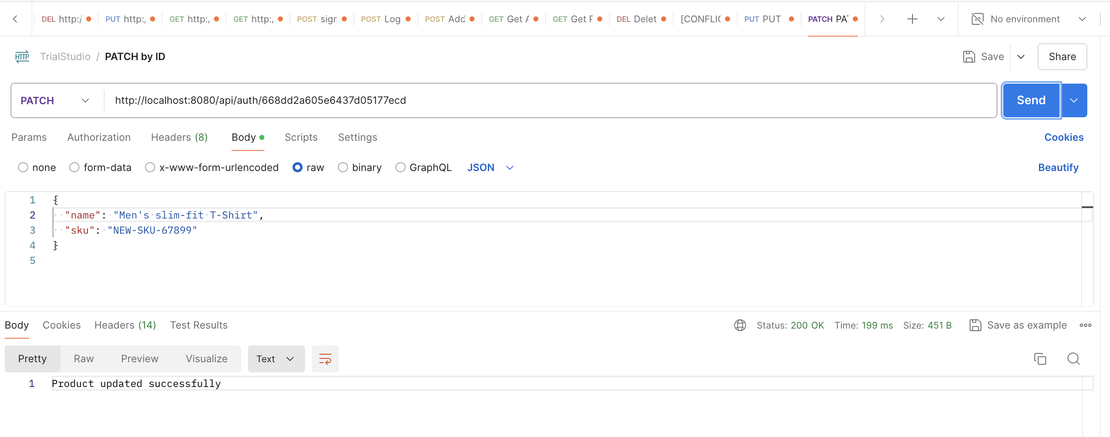

1. **Project Execution:**
2. **Landing Page:**

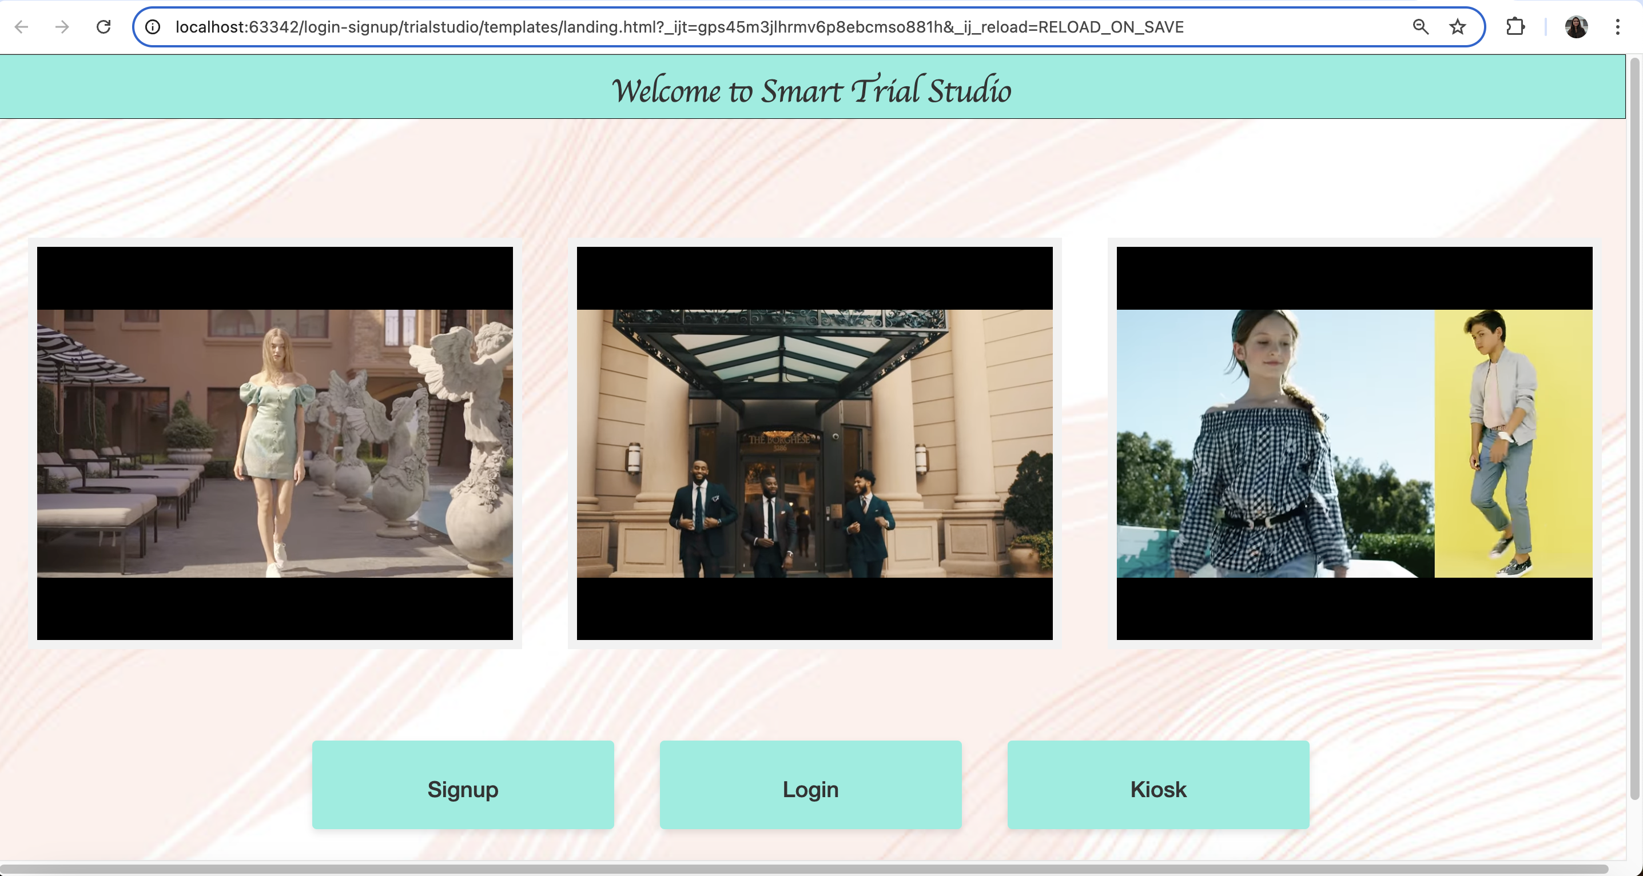

1. **Sing Up page:**

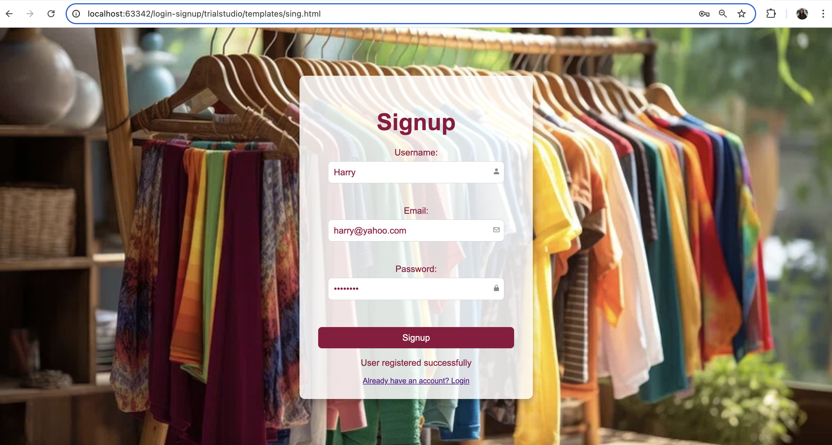

1. **Login Page:**

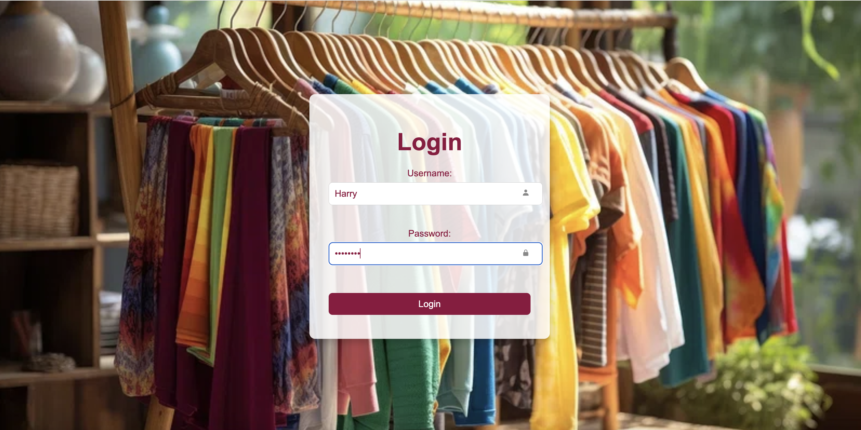

1. **Browser page:**

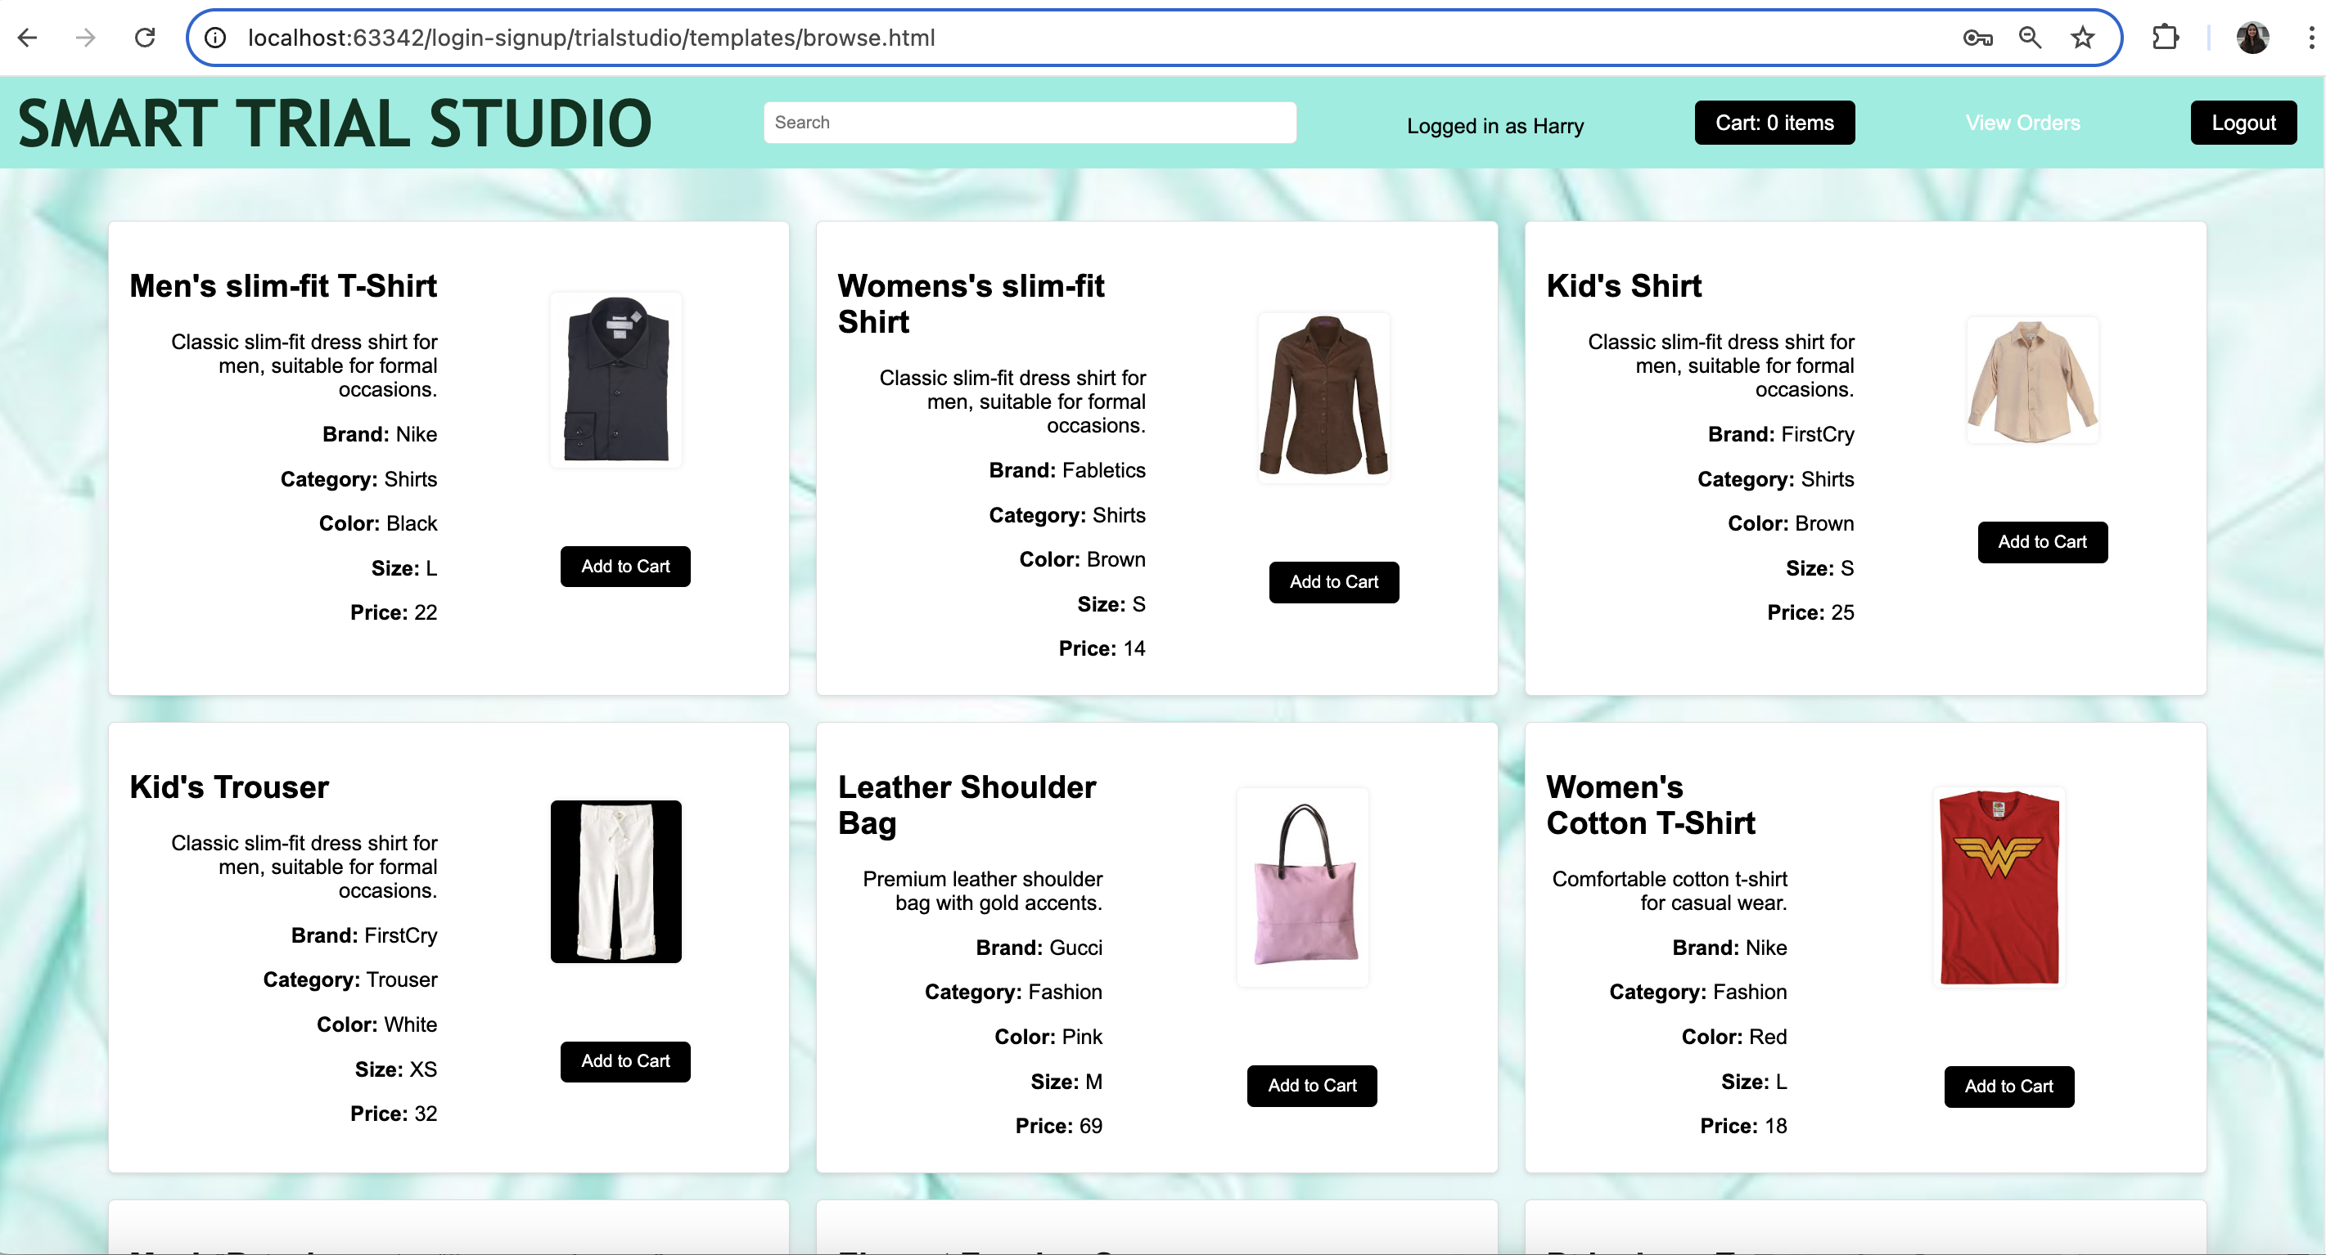

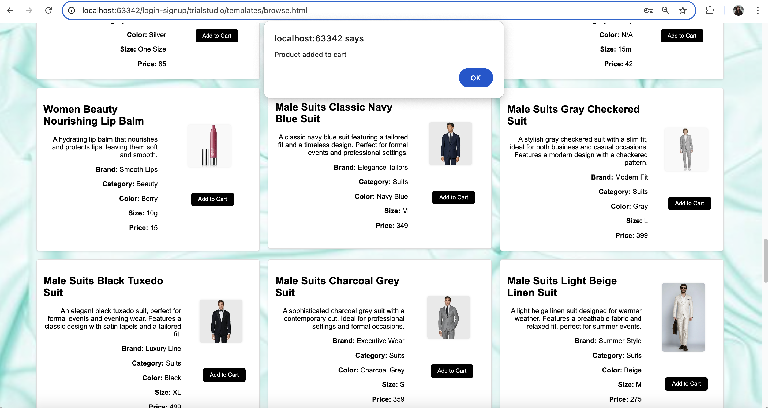

1. **Cart page**

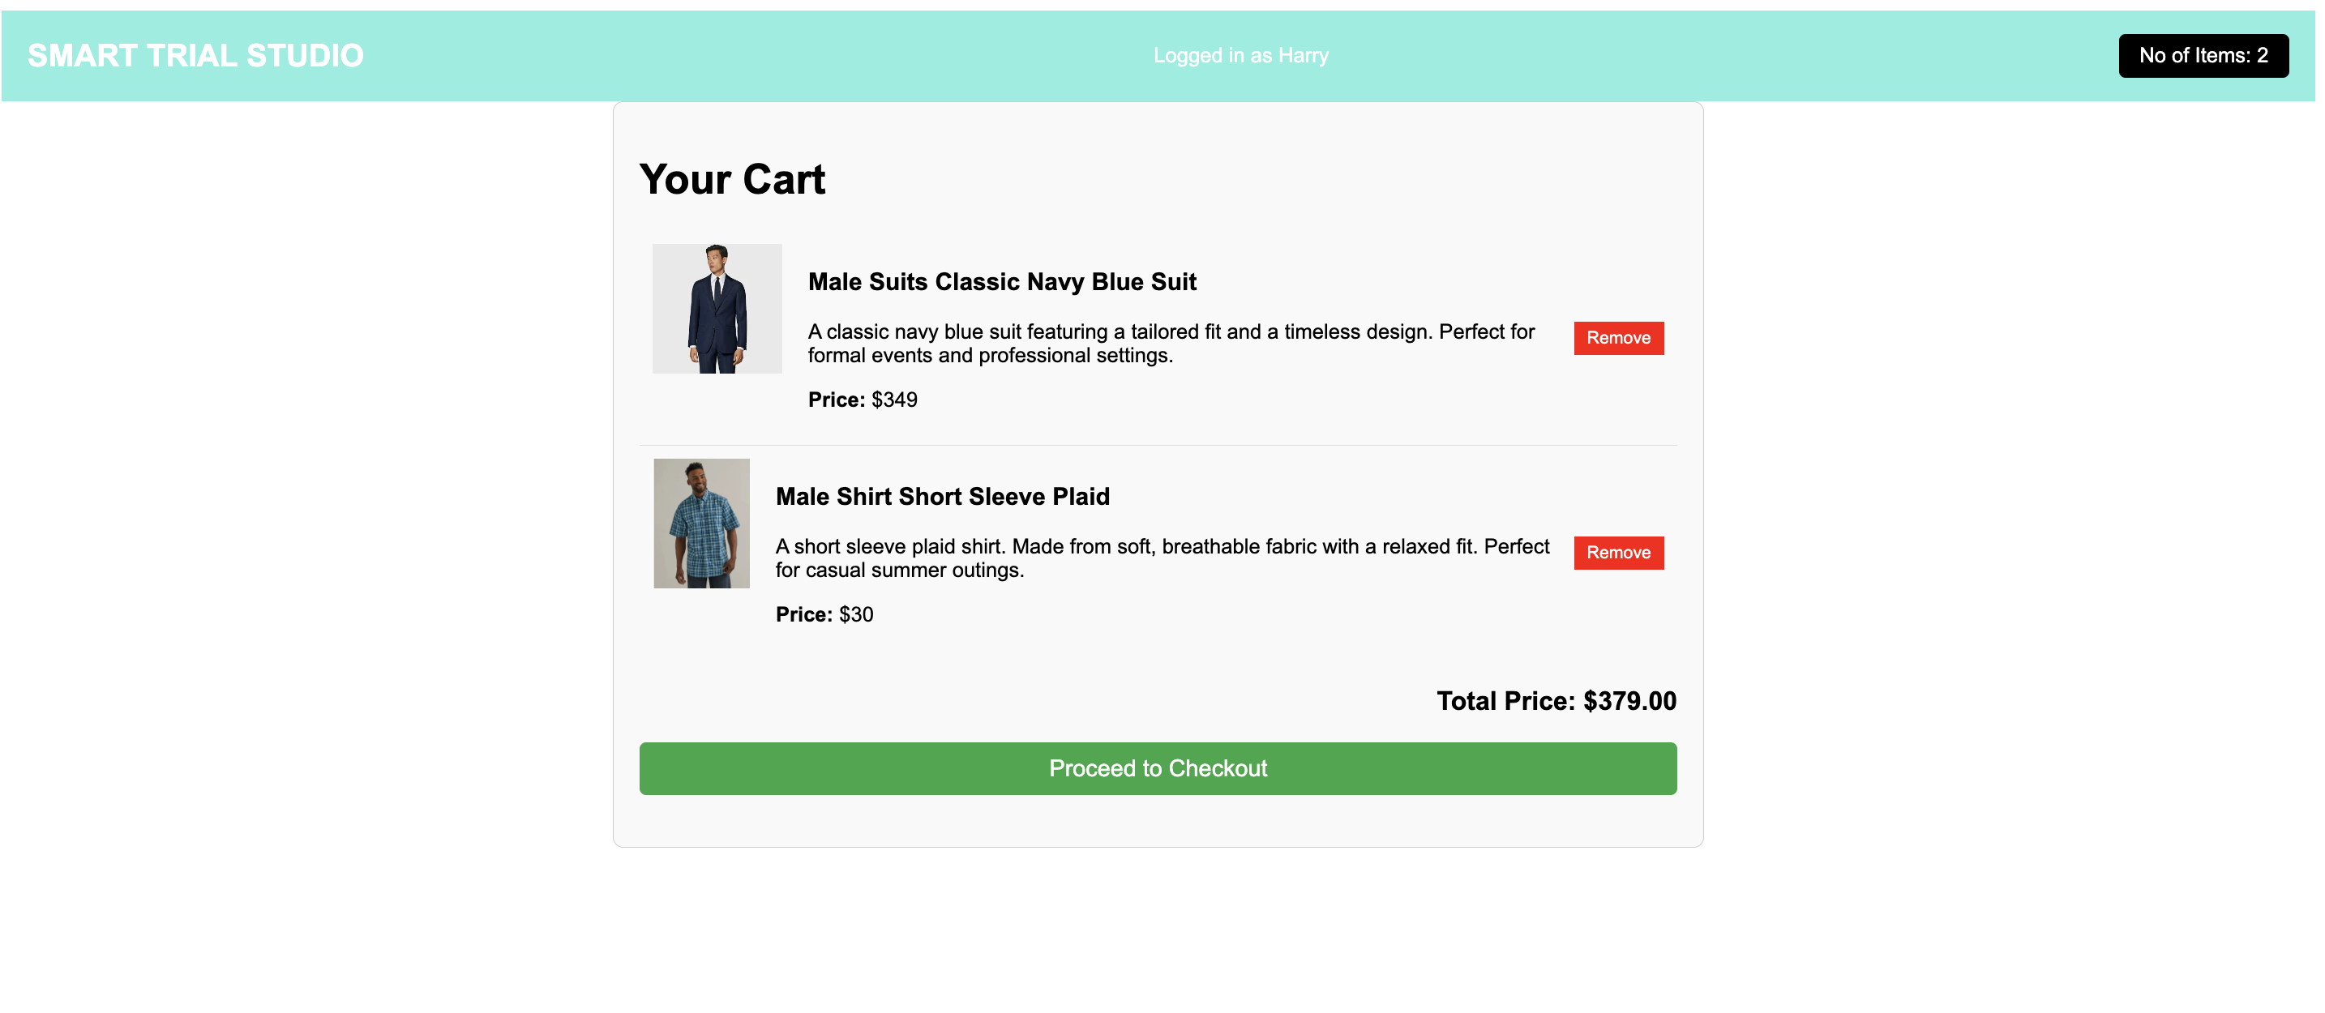

1. **Checkout page:**

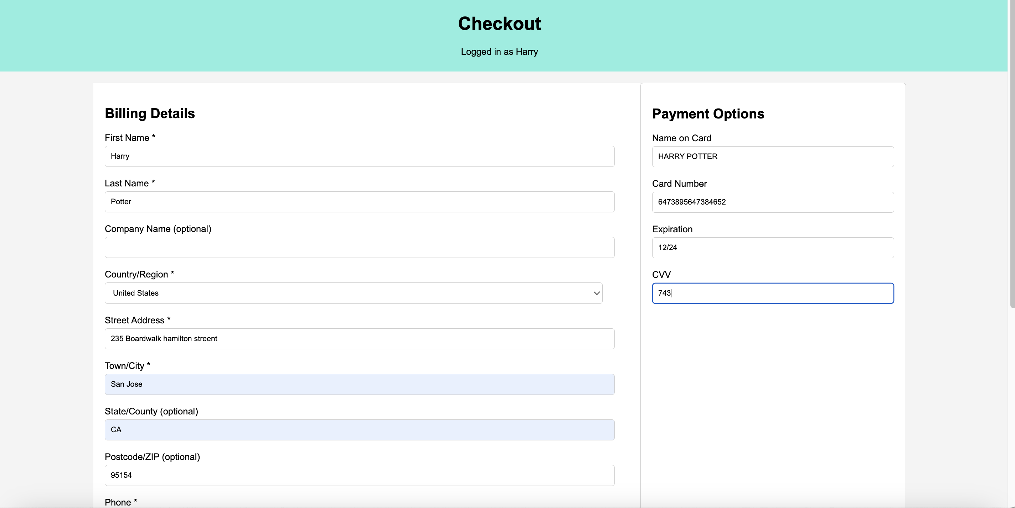

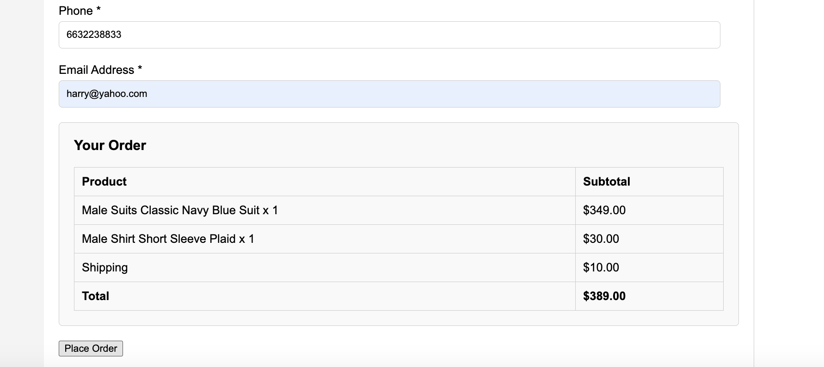

1. **Order confirmation**

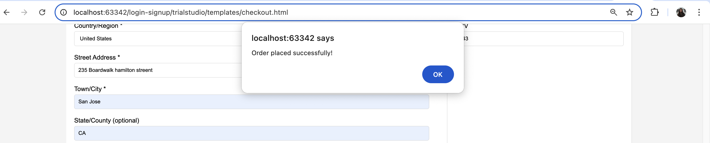

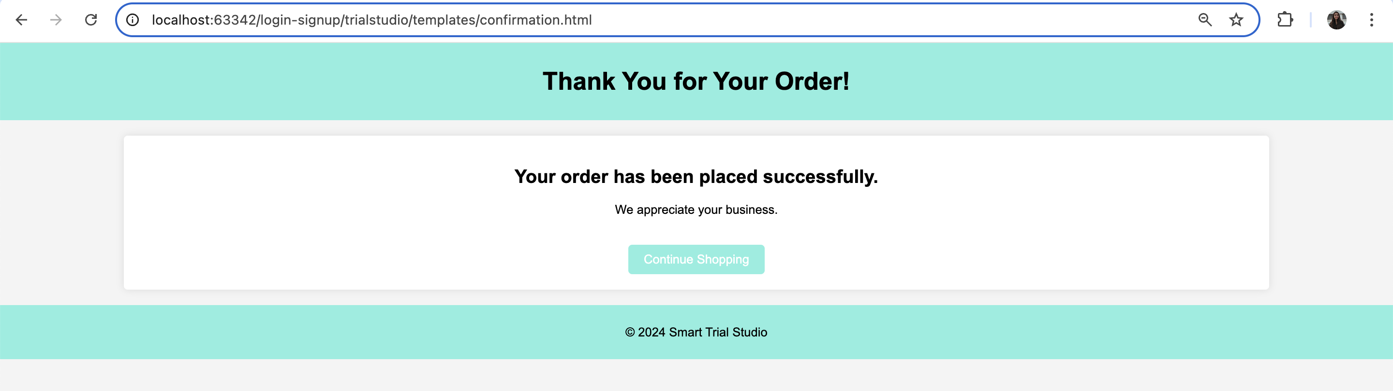

1. **Kiosk Page**
2. **Kids:**

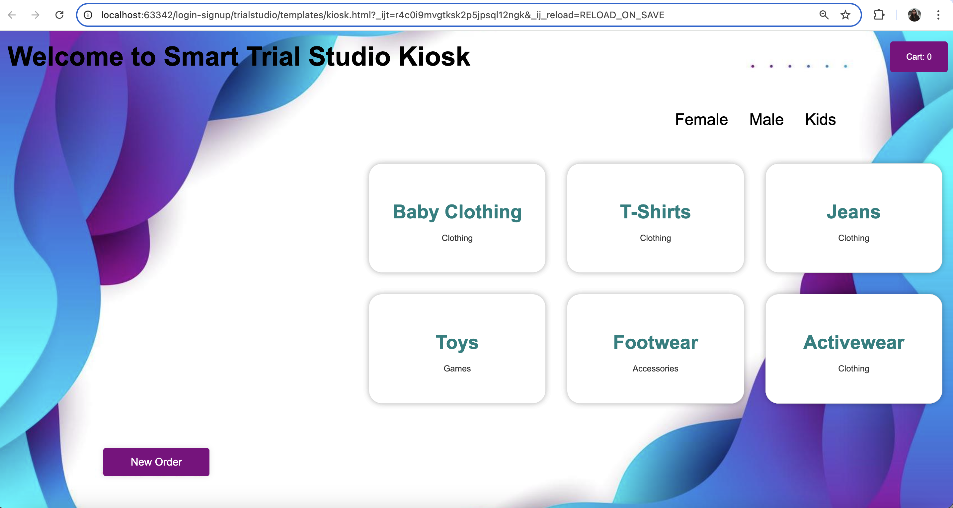

1. **Male:**

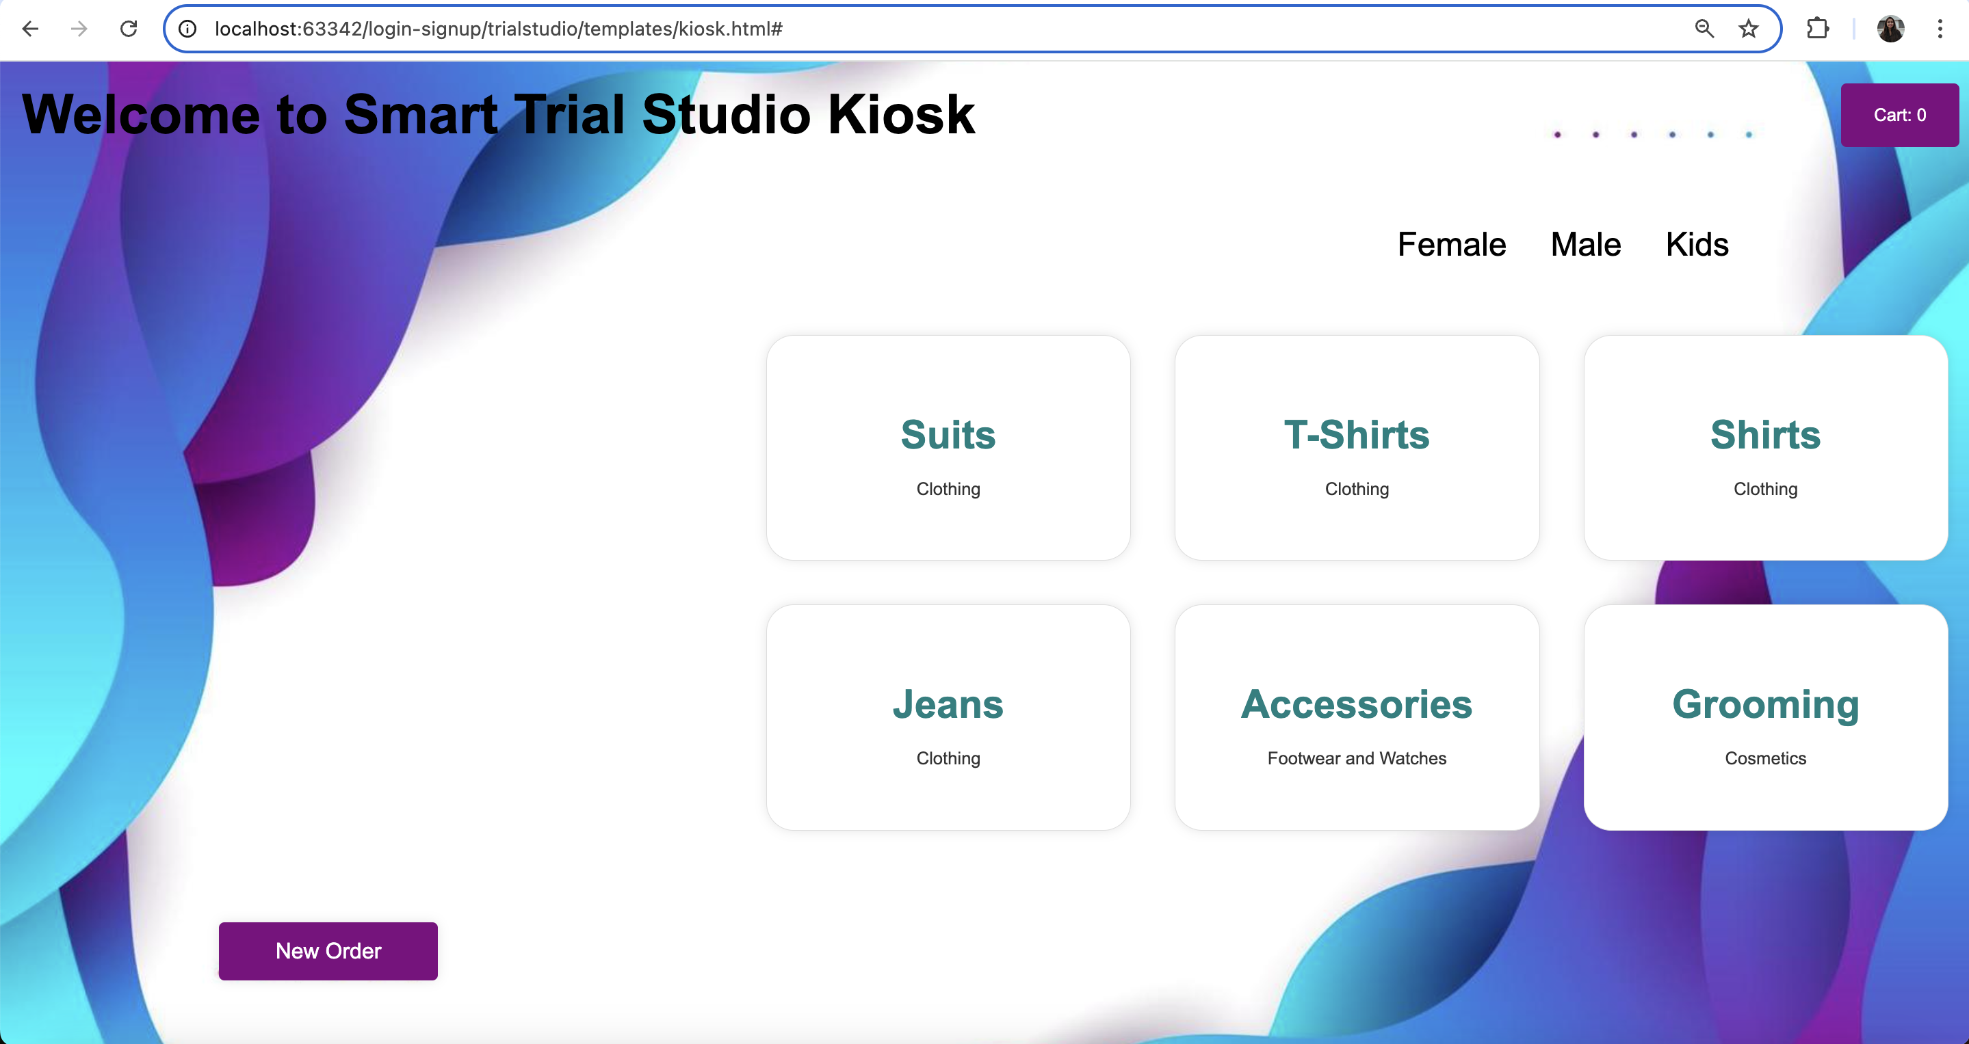

1. **Female:**

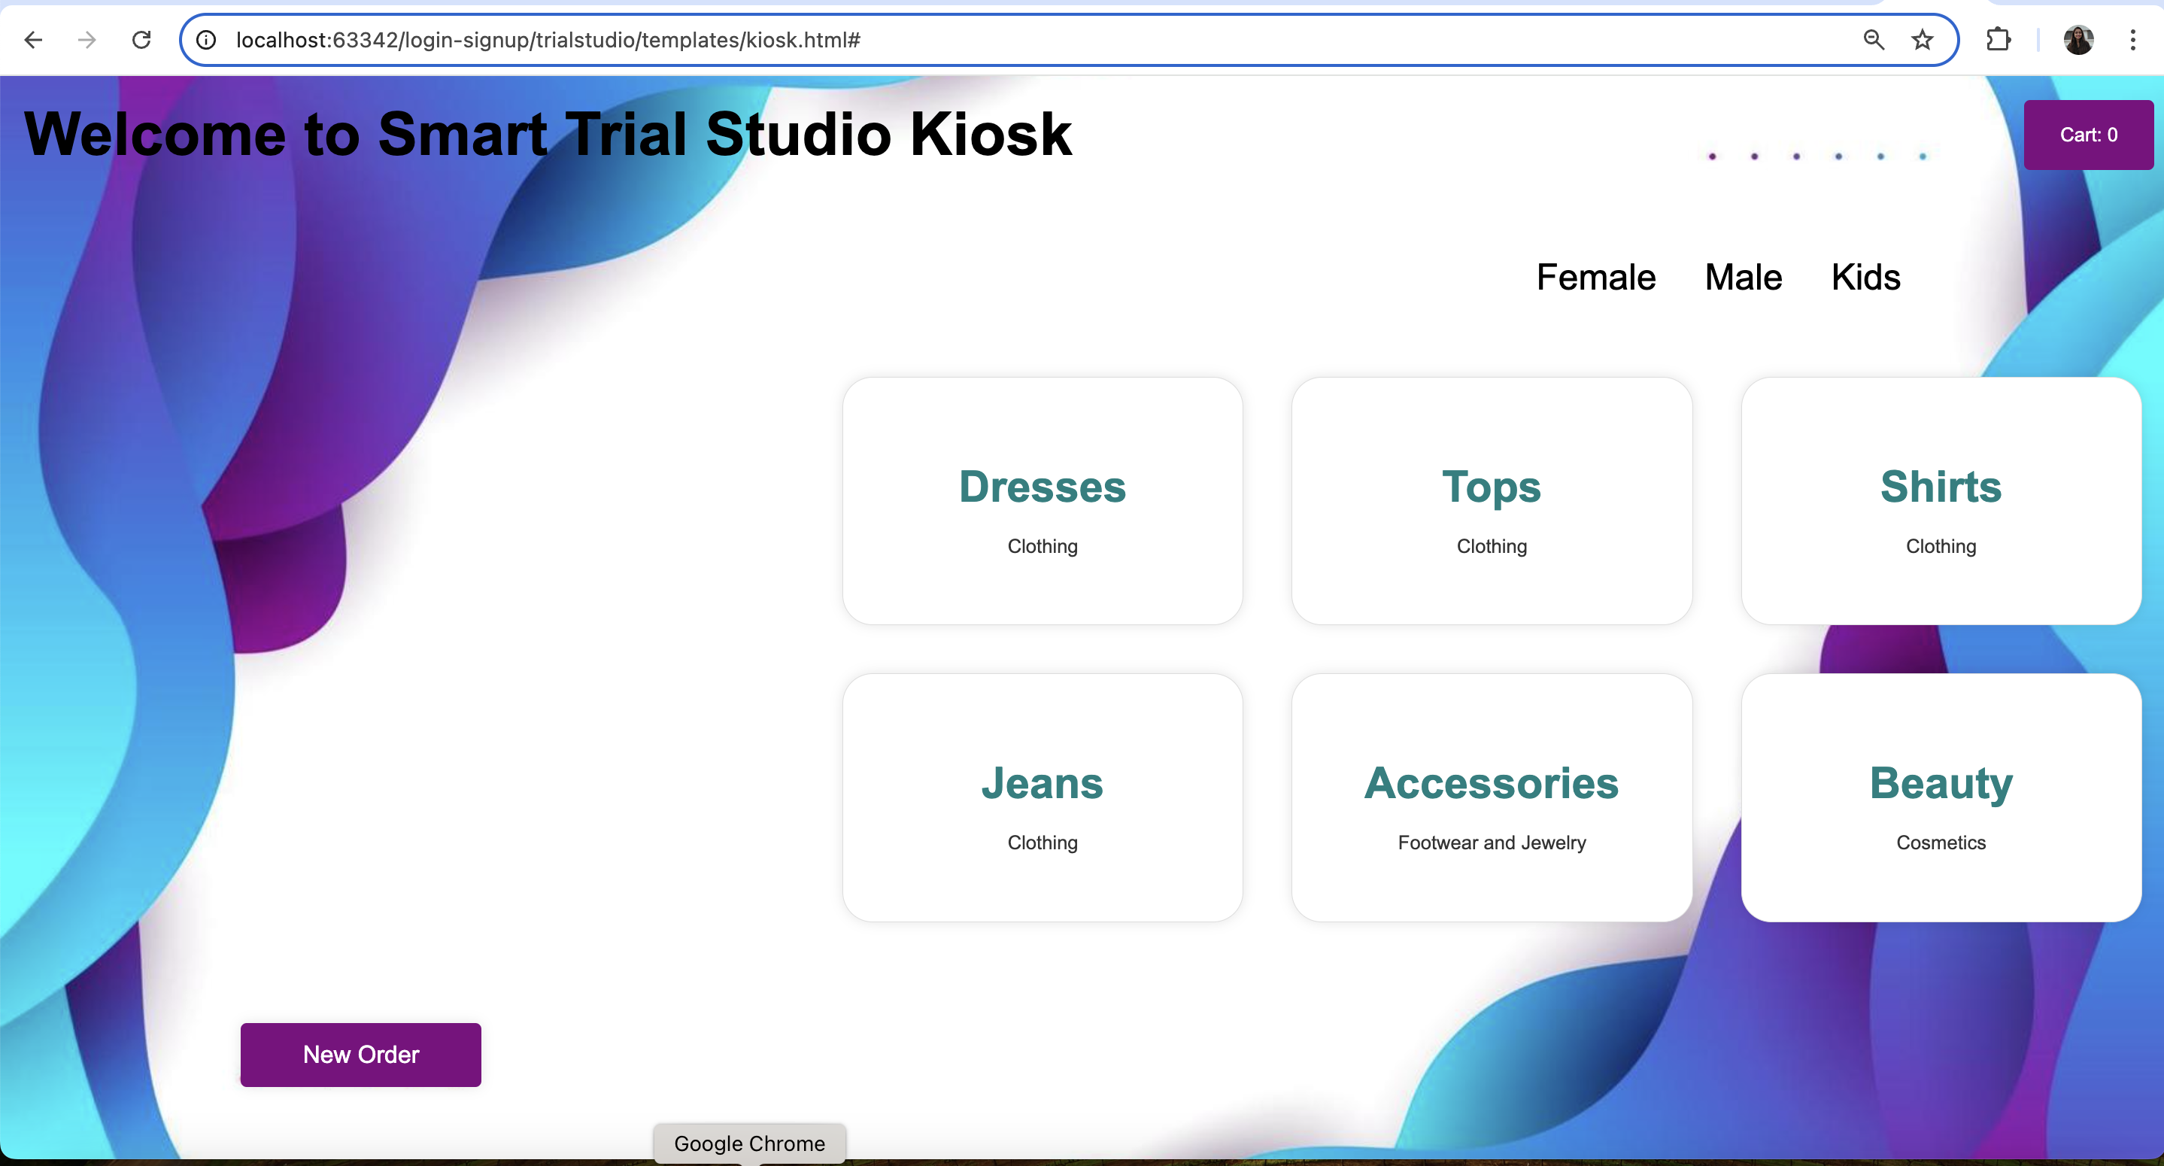

1. **Browse products on kiosk:**

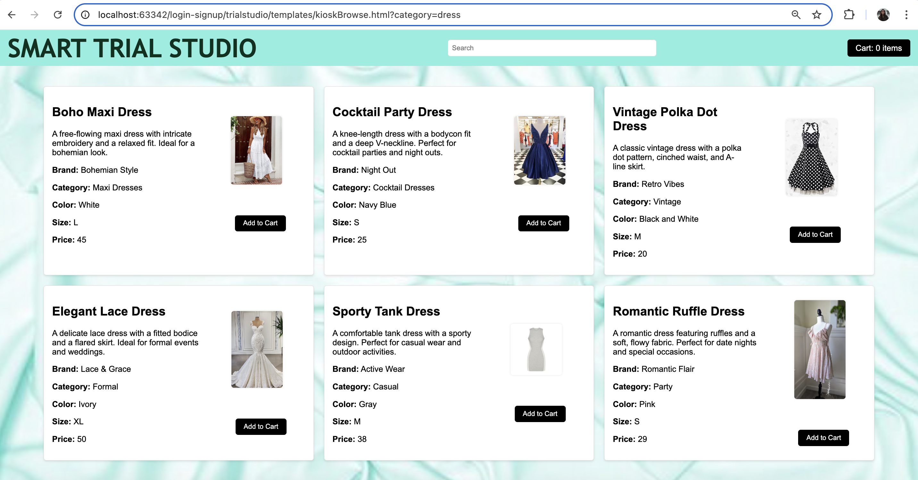

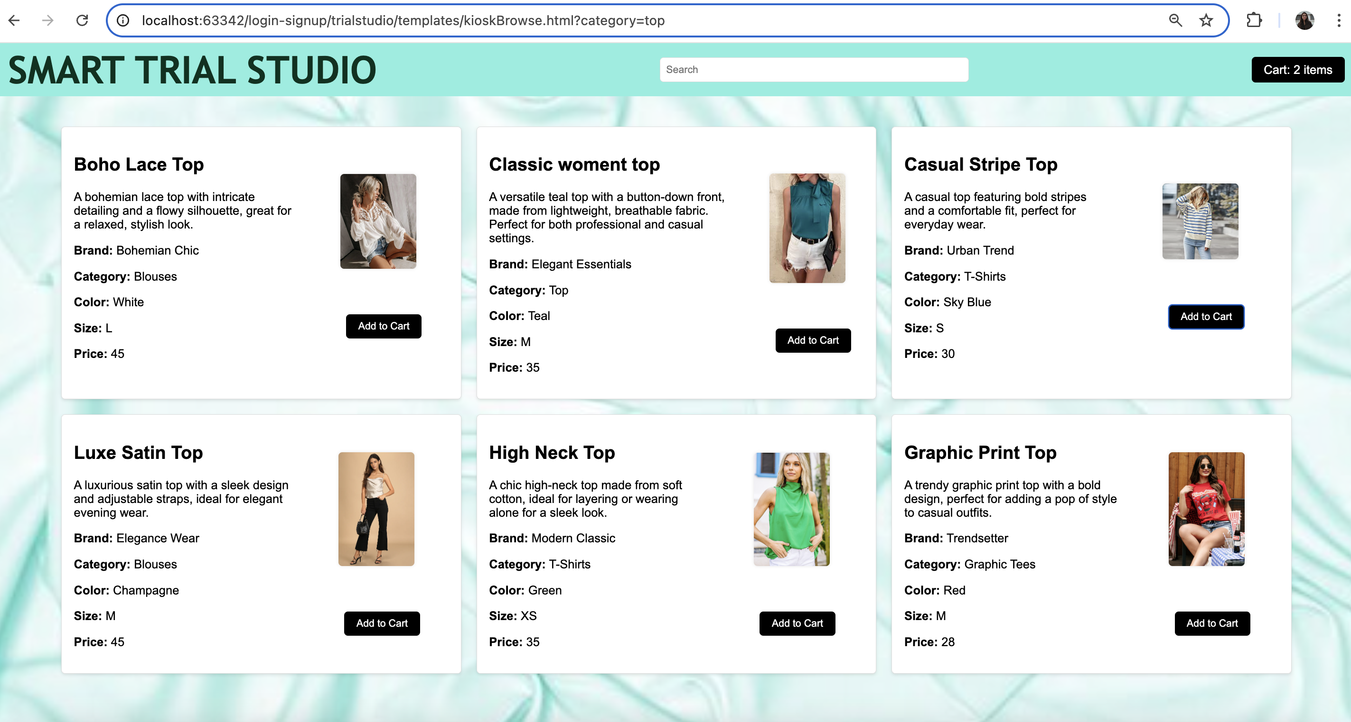

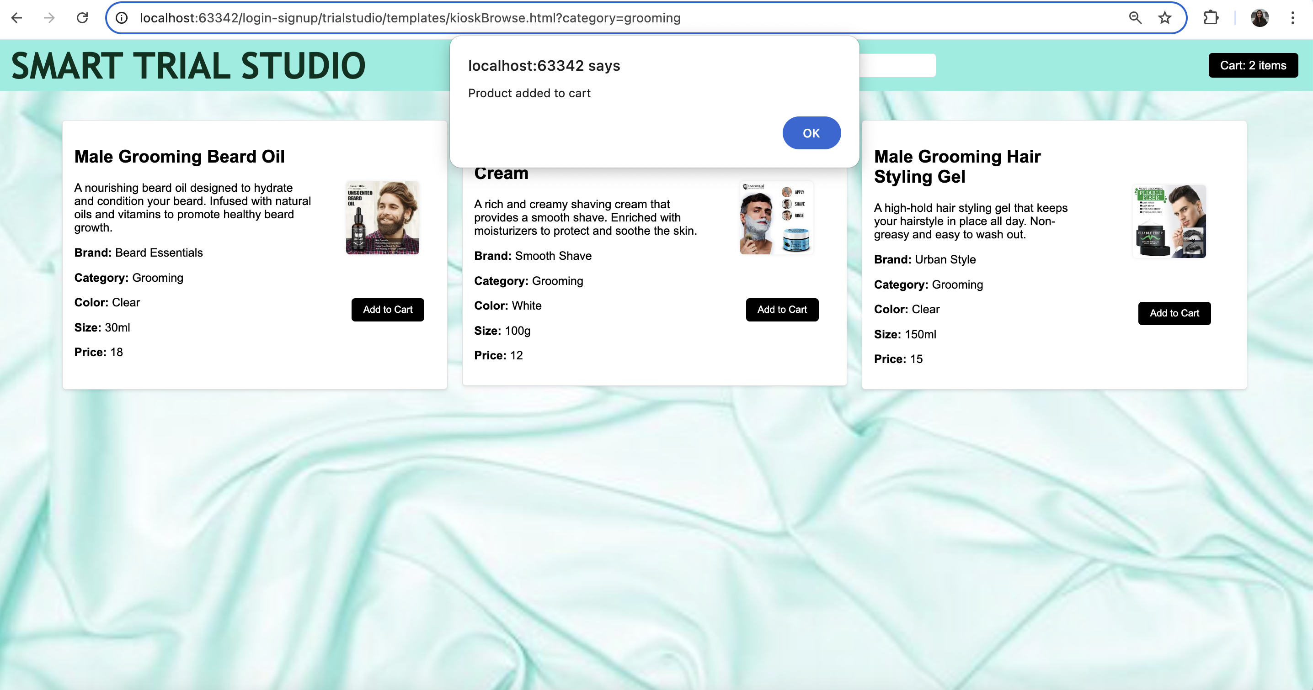

1. **Kiosk cart**

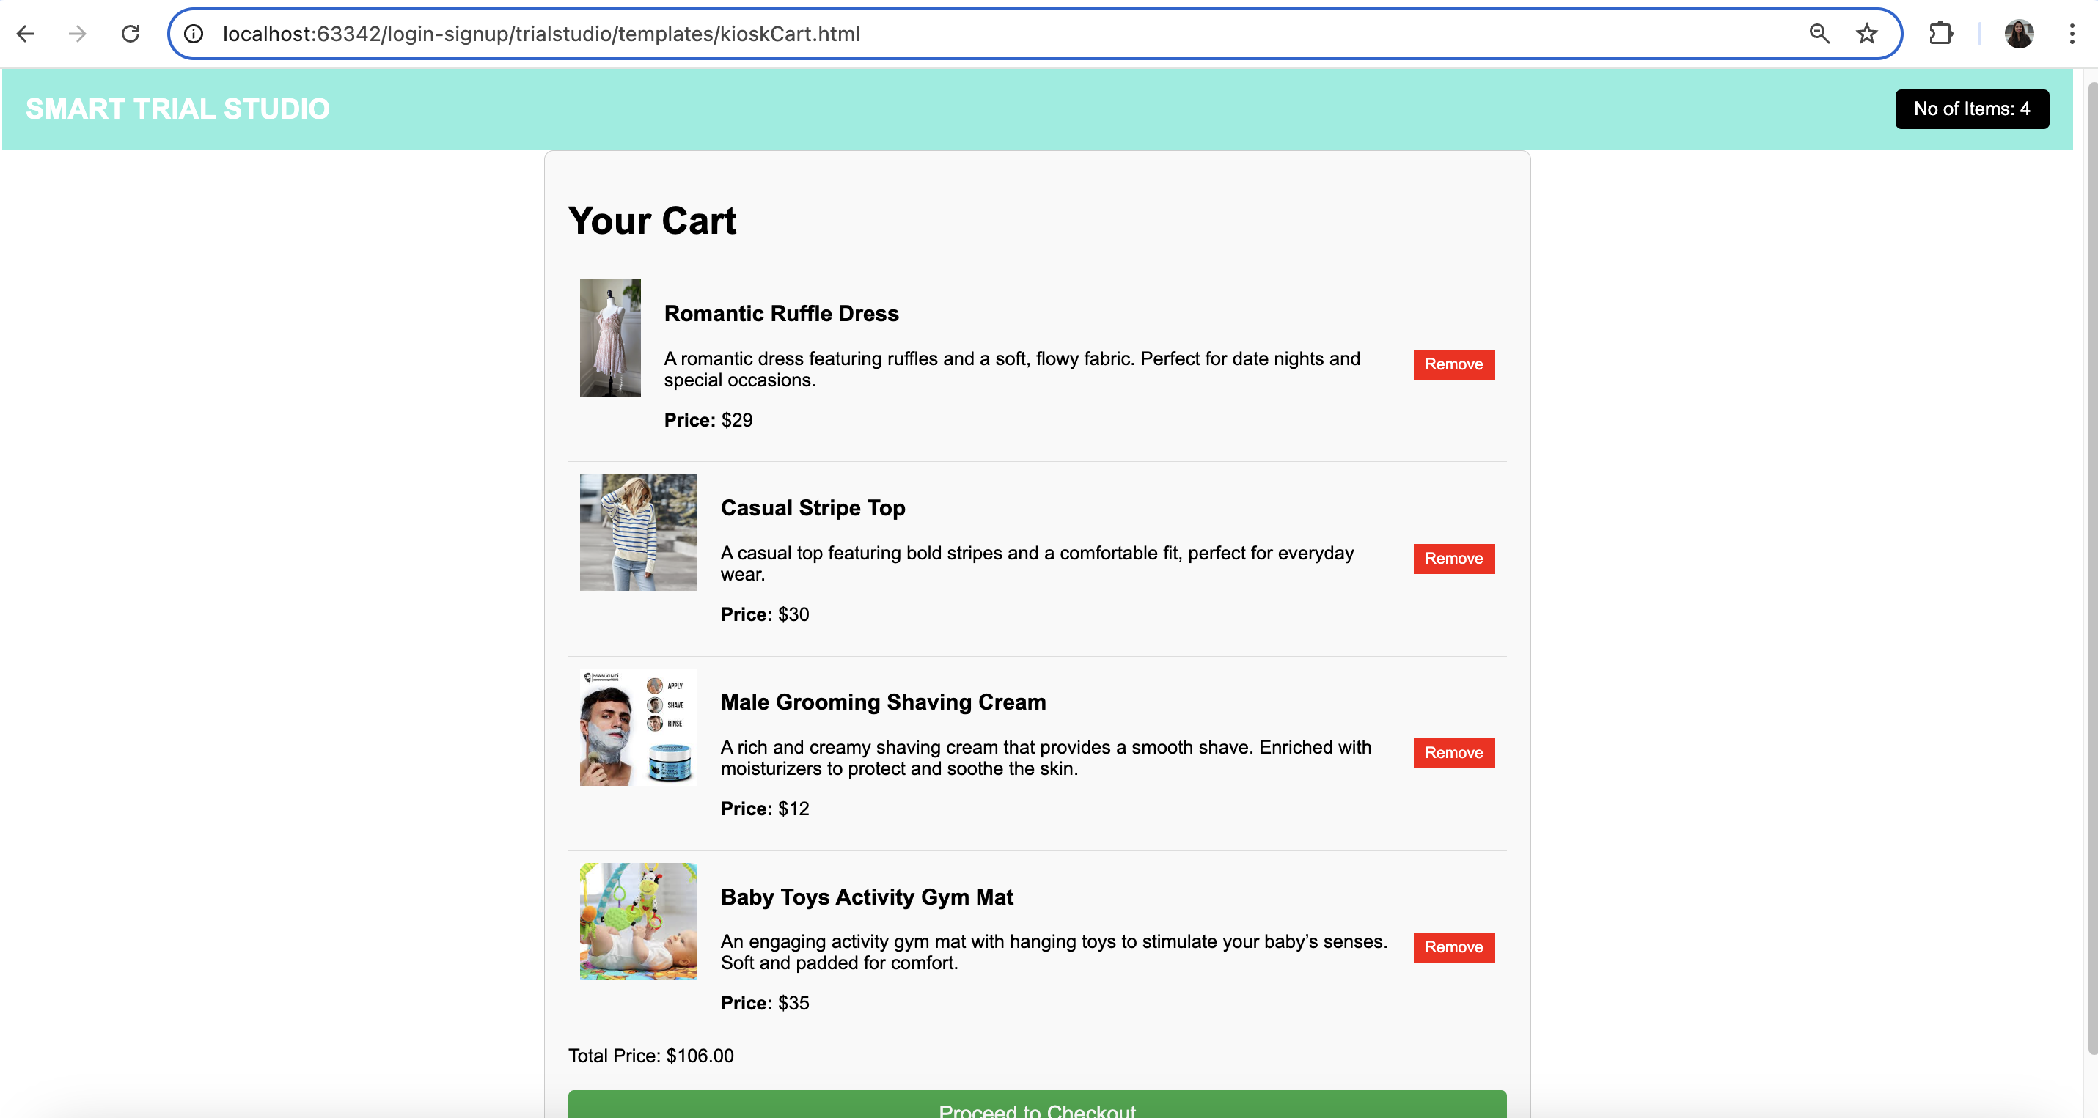

1. **Kiosk Checkout**

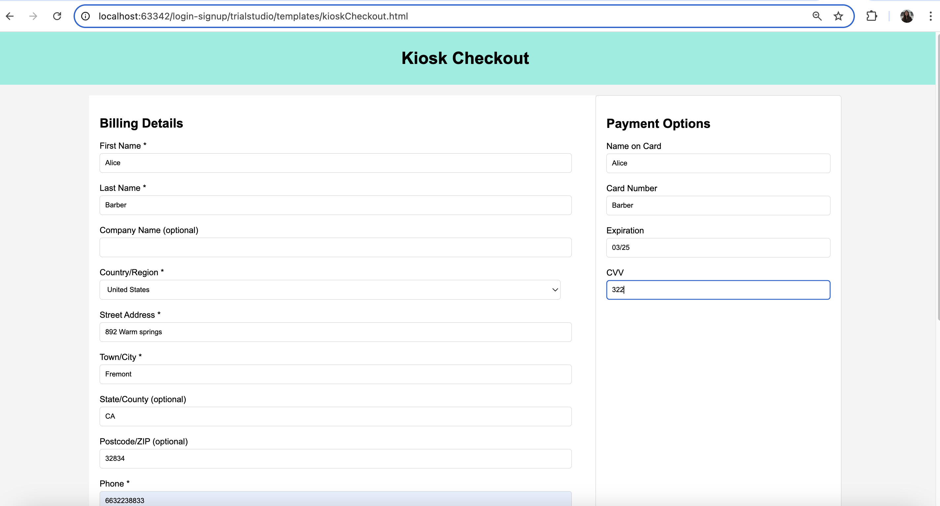

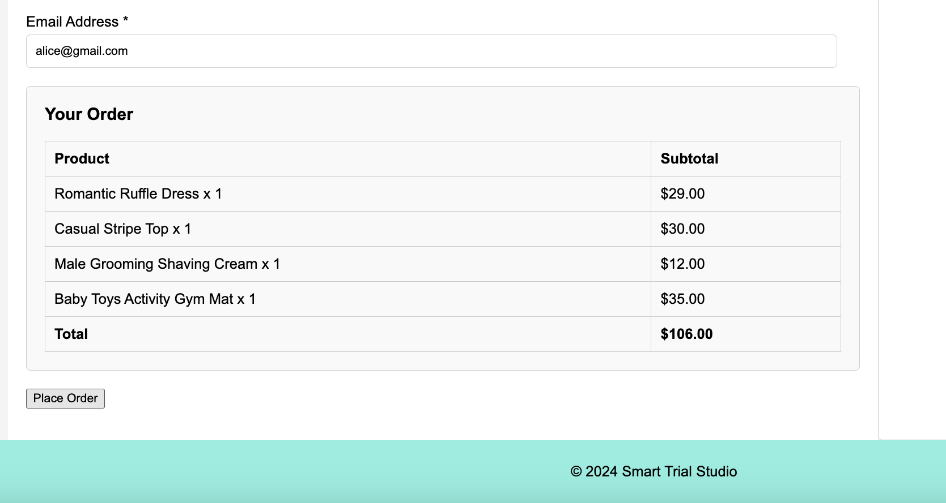

1. **Order Confirmation:**

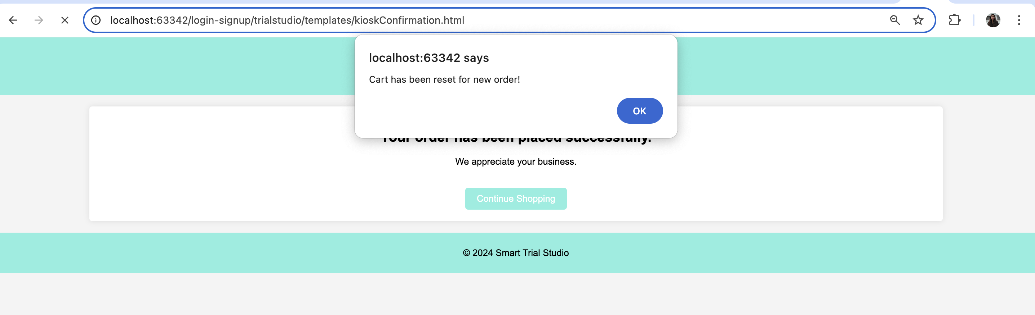

1. **Challenges:**
2. **Mongodb connection:** I faced some issues when trying to connect to MongoDB, which is the database I used for the project. The connection kept failing due to problems like incorrect settings and outdated software versions. After some troubleshooting, I figured out the issue was with the network configuration and the database driver. Once I fixed these, the connection worked, and I could continue with the project.
3. **Security Configs:** I had trouble with the security settings when connecting to MongoDB. The database kept blocking my access because the security configurations were too strict. After adjusting the permissions and making sure my credentials were correct, I was finally able to connect and move forward with the project.
4. **API execution:** I ran into issues while creating the REST API for my project. The problem was that some of the endpoints weren't working correctly because of mistakes in how I set up the routes and handled requests. After debugging and fixing the code, the API started functioning as expected, and I could connect it to the rest of the application.
5. **Completed Tasks:**

**Steps I followed to create the project:**

1. Setting up MongoDB from <https://www.mongodb.com/cloud/atlas/register>
2. Created Spring boot project structure from <https://start.spring.io/>
3. Created API in AuthController.java
4. Used POSTMAN to test all the API’s
5. Created web pages for Signup, Login, Browser and Cart, Checkout, Confirmation,

Kiosk home page, kiosk browser page, Kiosk cart, Kiosk checkout, kiosk confirmation.

1. Added many functionalities to make the API and web pages execute smoothly.

**PLEDGE:**

**I have neither given nor received unauthorized aid in completing this work, nor have I**

**presented someone else’s work as my own.**